|  |  |  |  |
| --- | --- | --- | --- |
| **SQL2K12 SSRS**  **Configuration Guide**  Information Systems Directorate  Data Management  November 4, 2013 | | | |
| **Revision History** | | | | | |
| **Issue** | | **Date** | **Author** | **Comments** | |
| 1.0 | | November 4, 2013 | Anne Labbe and Brian Williams | Initial Draft | |
|  | |  |  |  | |
|  | |  |  |  | |
|  | |  |  |  | |
|  | |  |  |  | |

TABLE of CONTENTS

DOCUMENT CONTROL 2

SQL Server SSRS Configuration Guide 1

Checklist of Items Required 1

CRM Installation 1

Introduction 2

What is SSRS? 2

Procedure to Configure SSRS 2

Procedure to find the SQL Reporting Server (SSRS) Service Account 2

Procedure to find the port for the SQL Reporting Server Service Account 4

Procedure to find/verify the TCP/IP Port for the SSRS backend database SQL Instance 6

Procedure to Configure SSRS 8

Service Account Link 9

Database Server 10

Web Service URL 11

Report Manager URL 12

E-mail Settings 13

Execution Account 14

Encryption Keys 15

Scale-out Deployment 16

Procedure to Set HTTPS 17

Install a Certificate for SSL 18

To configure a report server URL for SSL 18

To configure the reports URL for SSL 19

Procedure to Set SPN’s for the SQL Service Account Using TCP/IP 21

Procedure to Set SPN’s for the SQL Reporting Server Service Account 21

Procedure to Set the Configuration file to enable NTLM 21

Procedure to Set SPN’s for the SQL Reporting Server Service Account using AD 21

Procedure to check the browser settings 22

Procedure to Set Trusted for Delegation on the SSRS server 24

Procedure to set Trusted for Delegation for the SSRS Service Account 26

Run all software as Administrator 28

Use the 64 bit edition of I.E 30

Set I.E to automatically log on with username and password 31

Procedure to test the reports 33

Procedure to verify that Kerberos is being used 37

CONFIRMATION / VERIFICATION PROCESS IS SUCCESSFUL 39

CRM 2011 and SQL Server Reporting Services (SSRS) Configuration 39

Configuration of SQL Server Reporting Services for CRM 40

Installation account Prerequisite Permissions 40

Service account and SPNs 40

Configuration in SSRS for CRM 40

Installation of CRM Server 41

Get the ReportServer URL 41

Grant the Service Account Rights 41

Installation of CRM Reporting Extensions 45

SSRS Custom Data Source & Stored Credentials 48

CONFIGURE THE REPORT’S DATASOURCE 50

Setting up a Custom data source Account 53

CRM Reporting Management and Automated Emailing of PDF Reports 55

POST PROCESS CLEANUP 60

Delete Errant or Duplicate SPN’s 60

Check for Duplicate SPN’s 60

APPENDIX A 62

APPENDIX B 63

GLOSSARY 65

SIGNATURE SIGN-OFF 68

# SQL Server SSRS Configuration Guide

## Checklist of Items Required

* Name of SQL Instance which will house the SSRS databases: ____________________________________________________________
* Name of the SQL server that SSRS is installed on: ____________________________________________________________
* Name of SSRS service Account:

_____________________________________________________________

* Password of SSRS service Account:

_____________________________________________________________

* Port for SSRS reporting instance:

_____________________________________________________________

* Name of the Reporting Service database for the SSRS instance: _____________________________________________________________
* Name of the SQL Installation Account: _____________________________________________________________
* Password for the SQL Installation Account: _____________________________________________________________

### CRM Installation

* Name of the CRM Stored Credential Account: _____________________________________________________________
* Password for the CRM Stored Credential Account: _____________________________________________________________

## Introduction

This document covers the Database Administration Procedures required to configure SSRS for normal use. It assumes that SSRS has been installed but not configured. Certain application such as CRM and SharePoint will require custom configuration settings.

NOTE: This document should be performed by logging in as the SQL Installation Account as described in the SQL Installation Account document.

NOTE: The SQL Installation Account must be both local administrator and sysadmin on the database server that the reporting services database s will be created in. This is described in the SQL Installation Account document.

### What is SSRS?

SQL Server Reporting Services (SSRS) is a server-based report generation software system from Microsoft… The SSRS service allows developers as well as SQL administrators to connect to SQL databases and use SSRS tools to format SQL reports in many complex ways. SSRS also provides a 'Report Builder' tool for less technical IT workers to format SQL reports of lesser complexity.

SSRS is administered via a web interface and can be used to prepare and deliver a variety of interactive and printed reports.

(From: <http://en.wikipedia.org/wiki/SQL_Server_Reporting_Services>)

## Procedure to Configure SSRS

This document assumes that SSRS has been installed but not configured. The specific configuration setting chosen will depend on the application that will be using the reporting services. This document attempts to describe the configuration settings for the major applications including CRM and SharePoint.

NOTE: There are number of companion documents which should be referred to in addition to the current document. Some of these are the SPN document, and the SSRS installation document.

## Procedure to find the SQL Reporting Server (SSRS) Service Account

NOTE: This assumes that SSRS is installed and running.

1. Log onto the server hosting the SSRS instance.

* Use an account with Administrator privileges.

1. Open the SSRS Manager (Reporting Services Configuration Manager)

* Click on the windows icon, then on “All Programs”, then on “Microsoft SQL Server 2012”, then on “Configuration Tools”, and lastly on “Reporting Services Configuration Manager” to open.

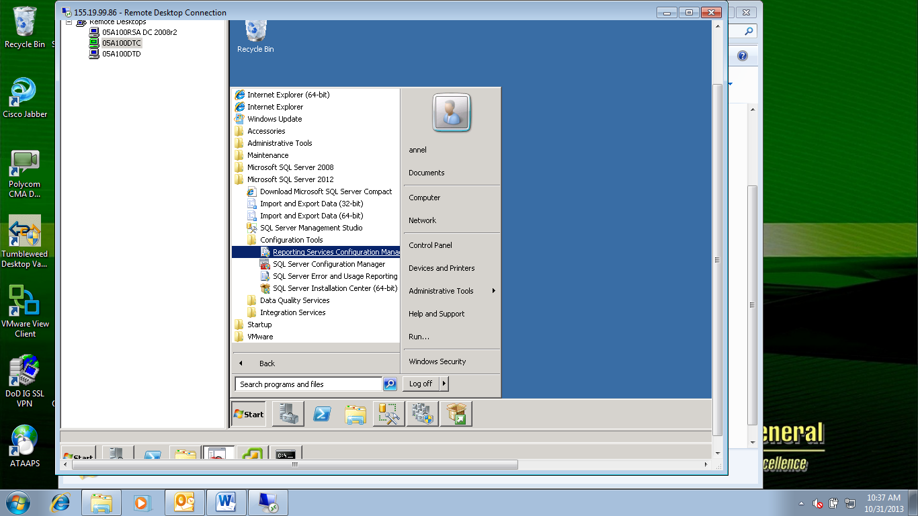

* The “User Account Control” box will pop up. Click “Yes” to accept.
* “Reporting Services Configuration Manager” opens

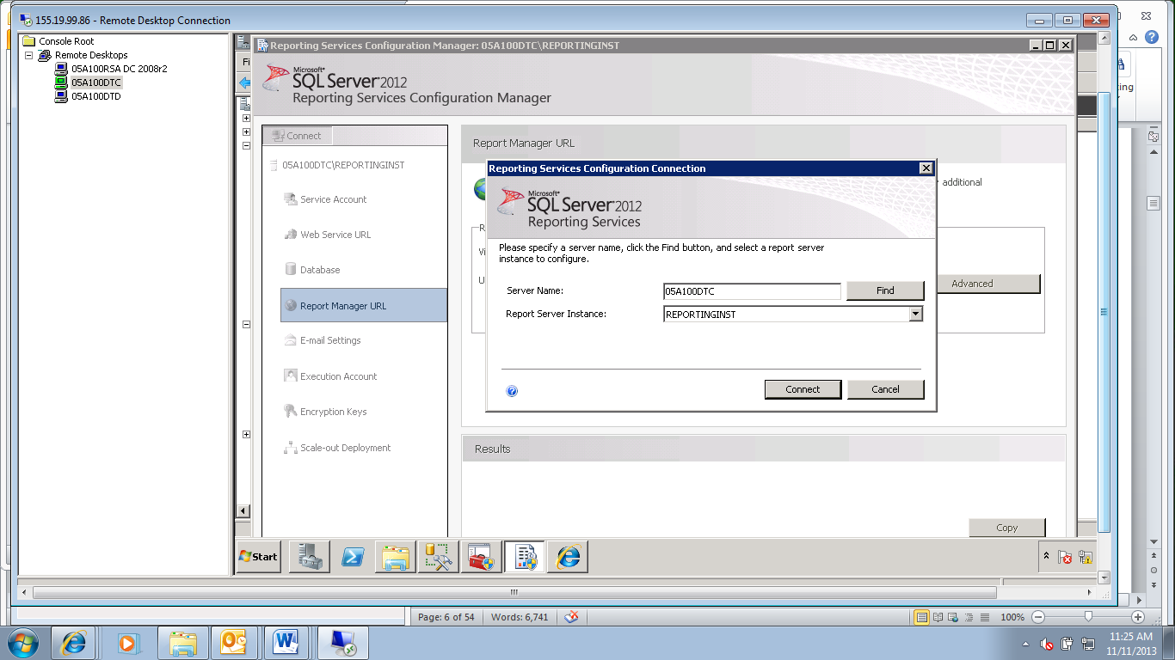

1. Connect to the reporting services instance.

* The “Reporting Services Configuration Connection” box will pop up.
* The server name should already be populated in the “Server Name:” textbox. If it is not, type it in.
* Choose the instance to configuration from the “Report Server Instance:” drop down box.
* Click the “Connect” button to connect.

1. Find the Reporting Services service account

* Click on the “Service Account” tab in the left hand column.
* The service account is visible on the right in the “Report Server Service Account” section.

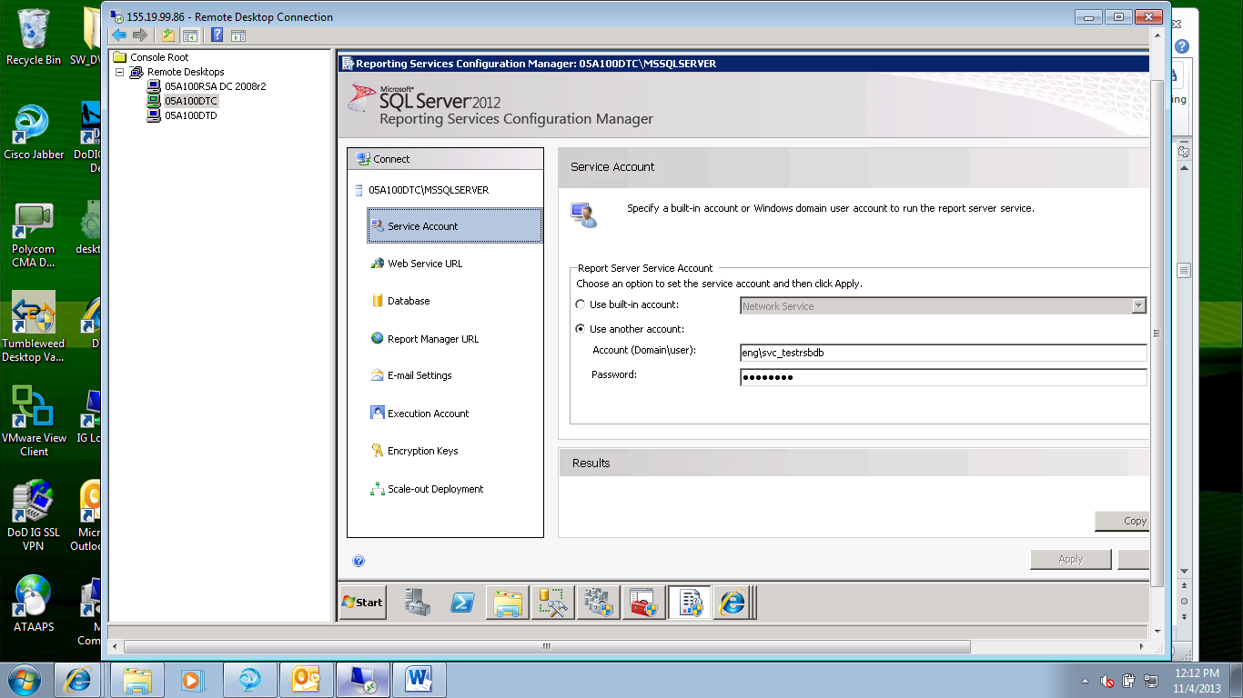

1. Make note of the service account for the next step.

NOTE: If this account is not a domain user account or is any built-in account please review and follow the SSRS installation instructions in the SSRS installation document.

## Procedure to find the port for the SQL Reporting Server Service Account

NOTE: If there is no URL configured that is ok. The purpose of this step is to make node of any port that has been configured if one is configured.

NOTE: This assumes that the default port of 80. If the default port has changed please replace 80 with the custom port in your notes.

NOTE: If this is the default SSRS instance it should have a port of 80. If this is a named instance of SSRS the ports should be the following:

2nd instance: Port 8080

3rd instance: Port 8090

4th instance: Port 8091

5th instance: Port 8092

6th instance: Port 8093

7th instance: Port 9094

Etc.

1. Get the port that SSRS is using

* Continuing from the “Reporting Services Configuration Manager” that was opened above.
* Click on the “Report Manager URL” link on the left.
* The “Report Manager URL” page will display on the right. It will show the URL and the port for SSRS. In the example below this is 80.

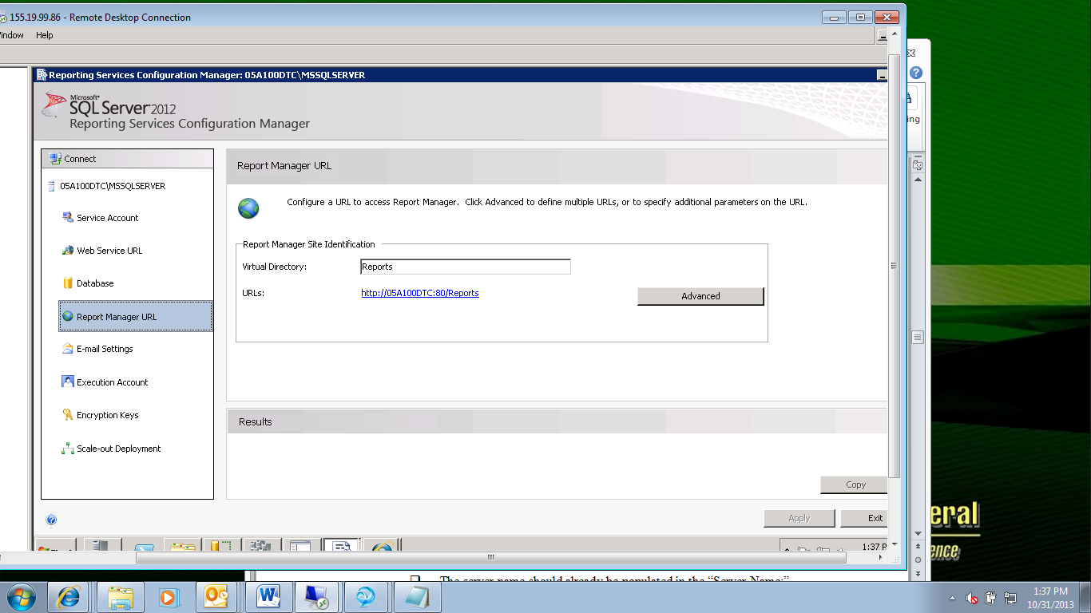

* Make note of this port. (In this case it is port 80.)

NOTE: If this is a named instance and it is using port 80 this must be changed per instructions below. Use the following chart:

2nd instance: Port 8080

3rd instance: Port 8090

4th instance: Port 8091

5th instance: Port 8092

6th instance: Port 8093

7th instance: Port 9094

Etc.

## Procedure to find/verify the TCP/IP Port for the SSRS backend database SQL Instance

NOTE: This step is performed by DBA’s.

1. Continuing from your RDP/Console session.

NOTE: Make a note of the static port in this step.

1. Make note of the database that SSRS uses.

* Continuing from the “Reporting Services Configuration Manager” above.
* Click on the ‘Database’ link in the left column.

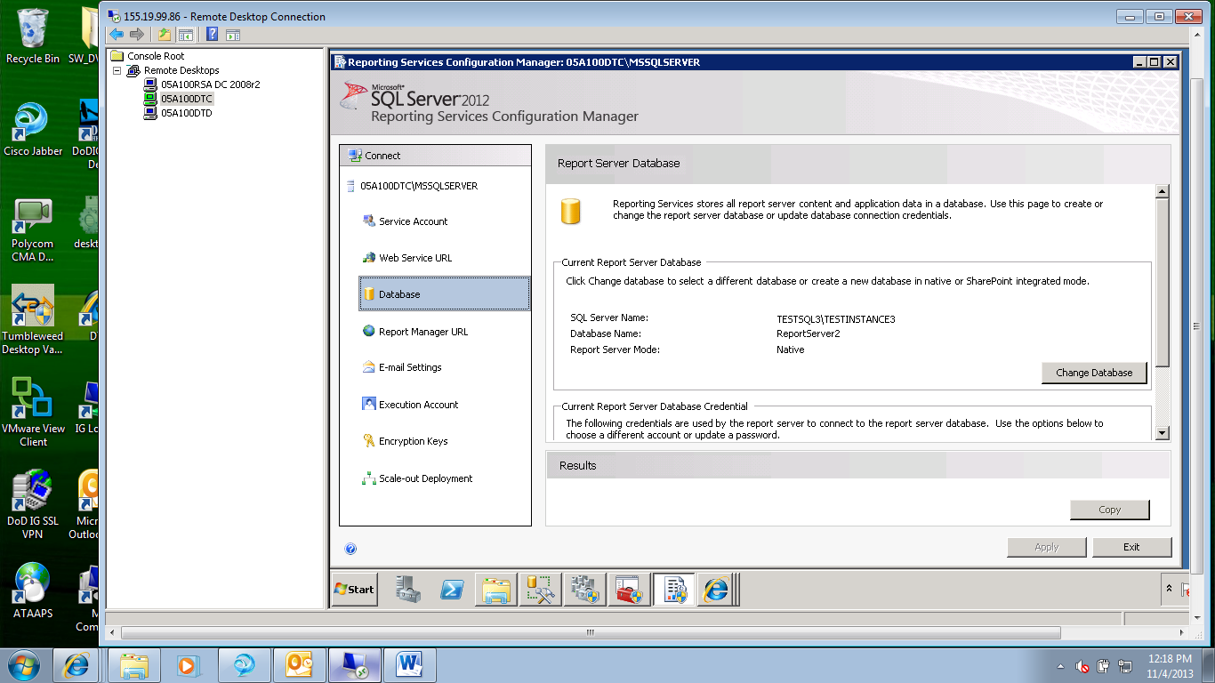

* If no database is configured, use the SQL instance name given to you as part of the prerequisites for this document.

1. Continuing from the “Sql Server Configuration Manager” window, get/verify the port of the SQL instance.

* Open the “SQL Server Configuration Manager (Local) node.
* Expand “SQL Server Network Configuration” and highlight “Protocols for <INS-NAME>”.

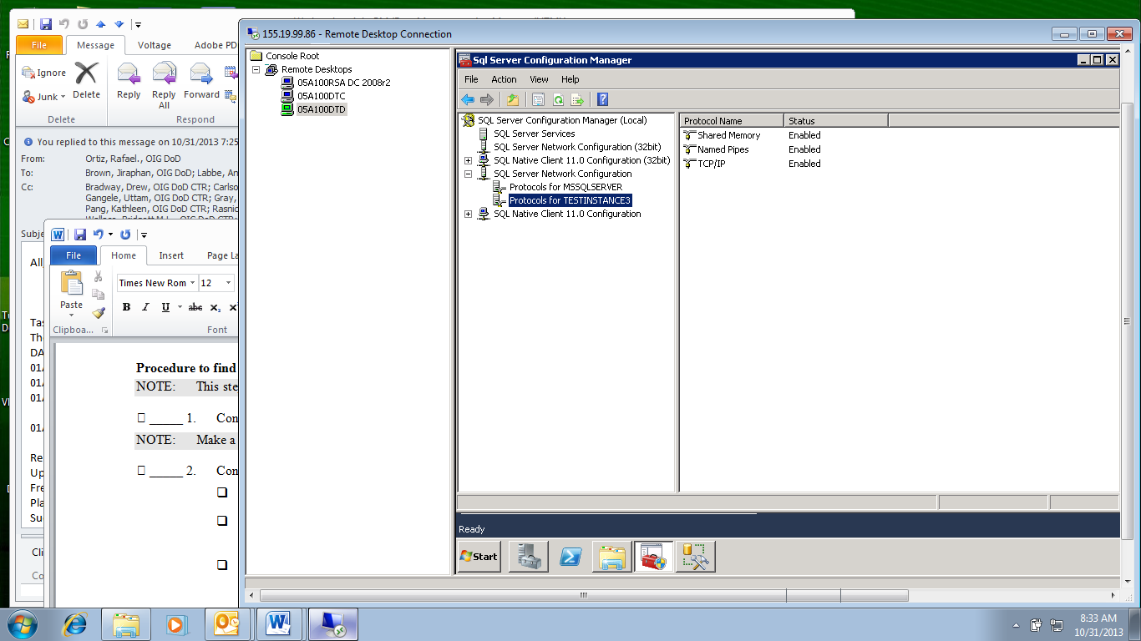

* In the right-hand pane, double-click “TCP/IP”.
* The “TCP/IP Properties” window displays.

1. Find the port used.

* Click on the “IP Addresses” tab.
* Scroll down to the last section to find the port listed. If a dynamic port is listed cut and paste that port into the static TCP/IP port box (last box).

NOTE: Make a note of the static port for setting Kerberos in this step. In this example it is 53024.

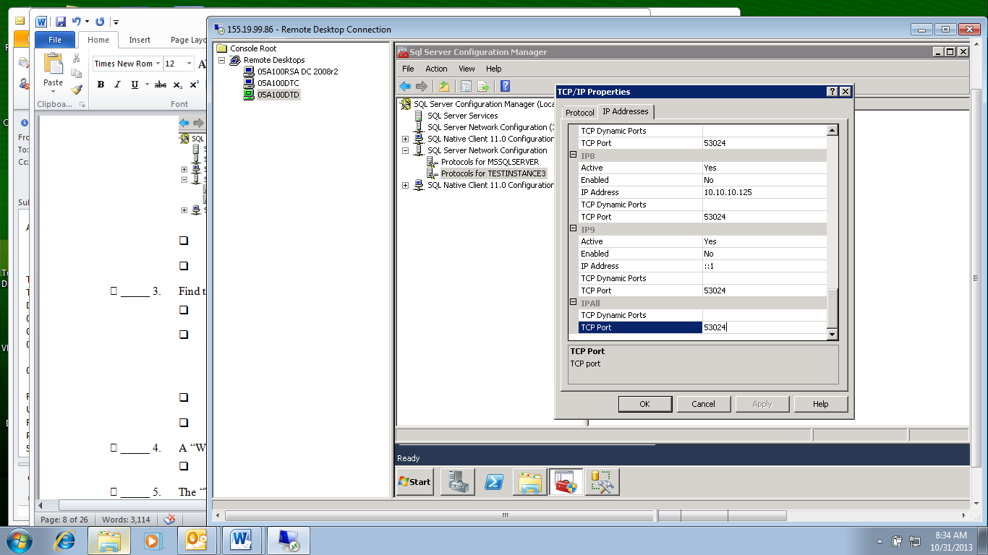

1. Click “OK” to close the “TCP/IP Properties” window.
2. Click the “X” in the upper right corner of the “SQL Server Configuration Manager” window.

* The only window still open should be the “Reporting Services Configuration Manager”.

## Procedure to Configure SSRS

NOTE: Use “MSSQLSERVER” for the default instance name, the named instances have their assigned names taken from the installation.

1. Continuing from the “Reporting Services Configuration Manager” window open from the previous step.

* You should still be connected to the reporting services instance that you want to configure.
* You should see the following screen:

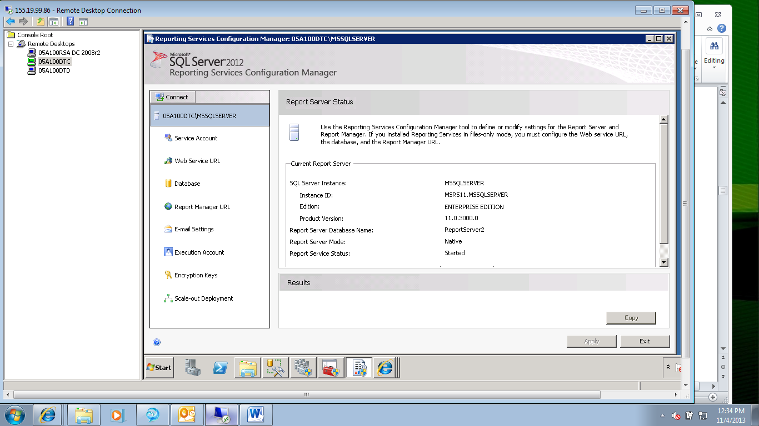

### Service Account Link

1. Click on the service account link in the left hand column.

* Verify that a domain user account is being used to run SSRS.

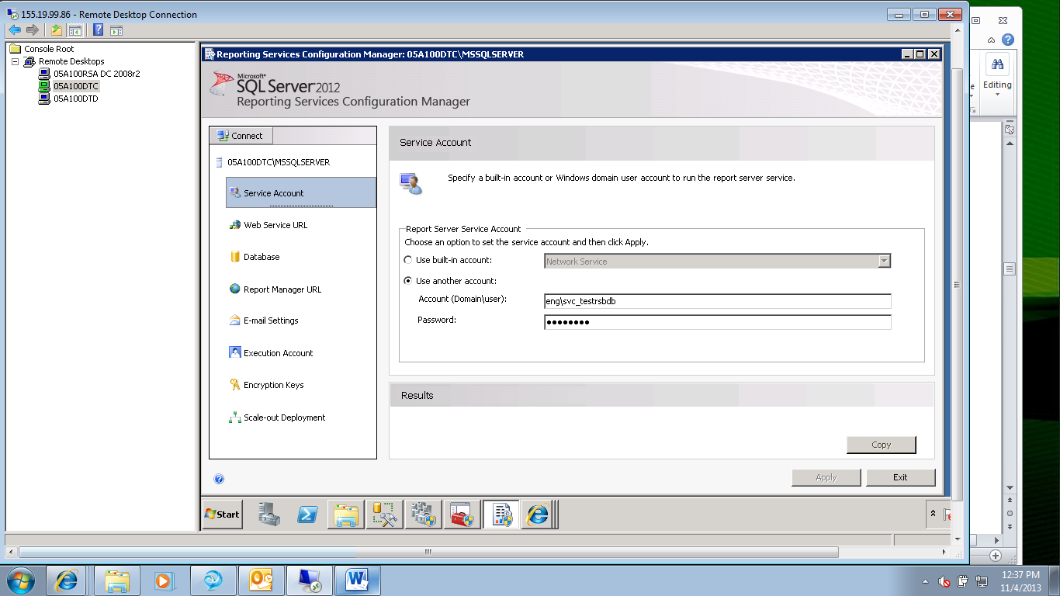

* If the account is not a domain user account, stop here and return to the SSRS installation document for instructions.

1. Set up the database to host the reporting services databases.

* Click on the “Database” link in the left hand column.
* Click the “Change Database” link on the right. The Report Server Database Configuration Wizard” will open.

1. The “Action” link on the left will already be chosen.

* Click the radio button which says “Create a new report server database.”
* Click “Next”.

### Database Server

1. The “Database Server” link on the left will be chosen.

* In the “Server Name” textbox on the right, type in the name of the SQL Server instance that will house the SSRS databases.
* Leave the “Authentication Type:” drop-down box selected to “Current User – Integrated Security”.
* Click the “Test Connection” button.

NOTE: The success of this test depends on the logged in account having sysadmin access to the SQL instance specified. If this is not the case add login rights to the SQL instance and retest the connection.

* A “Test Connection” box should pop-up and say “Test Connection Succeeded.)
* Click “OK”. This will close the pop up box.
* Click “Next” to continue.

1. The “Database” link on the left will be chosen.

* In the “Database Name:” textbox the default name of “ReportServer” will display. This default name should be used for the default SSRS instance only. (Please use the name supplied.)
* Type the name for the “ReportServer” into the textbox.
* Leave the rest of the boxes at default.

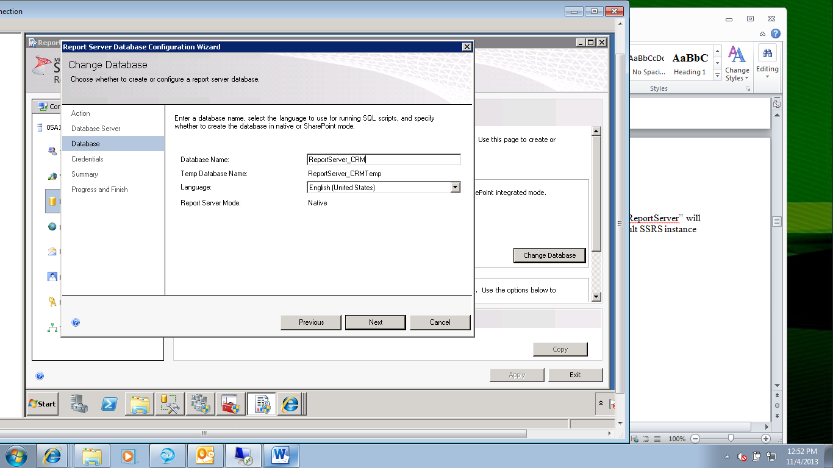

* Click “Next” to continue.
* Leave the “Authentication Type:” drop down box set to “Windows Credentials”.

1. In the “User name (Domain\user)” textbox type in the user account of the SSRS service account. The “Credentials” link on the left will be chosen.

* Service account that was supplied above.

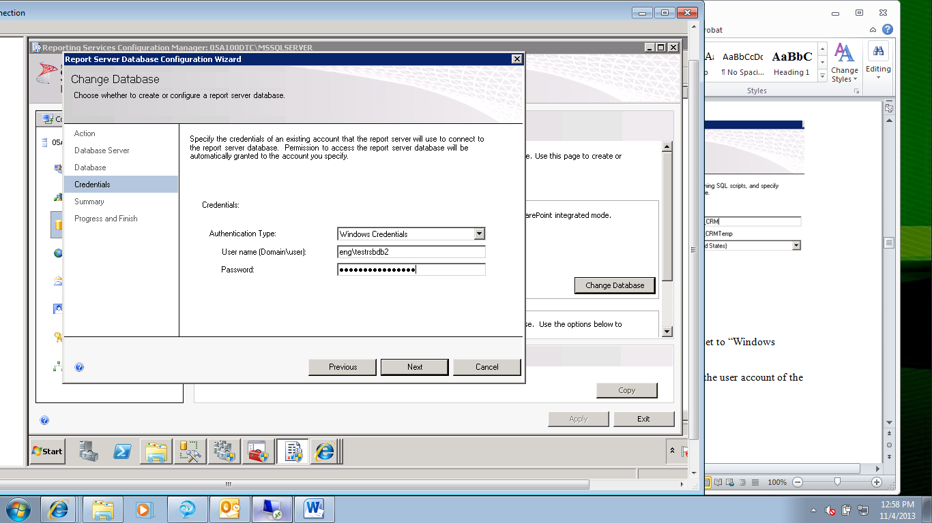

* Click “Next” to continue.

1. The “Summary” link on the left will be chosen.

* Review the information shown and click “Next”.

1. The “Progress and Finish” link on the left will be chosen.

* Wait until the installation completes.
* The Results of the installation should appear in the “Results” pane.

### Web Service URL

1. Back in the SSRS Configuration Manager

* Click on the “Web Service URL” link on the left.

1. Set the port.

* If this is the default instance leave the port at 80, else if this is a named instance set the port according to the following list:
* 2nd instance: Port 8080
* 3rd instance: Port 8090
* 4th instance: Port 8091
* 5th instance: Port 8092
* 6th instance: Port 8093
* 7th instance: Port 9094
* Etc.

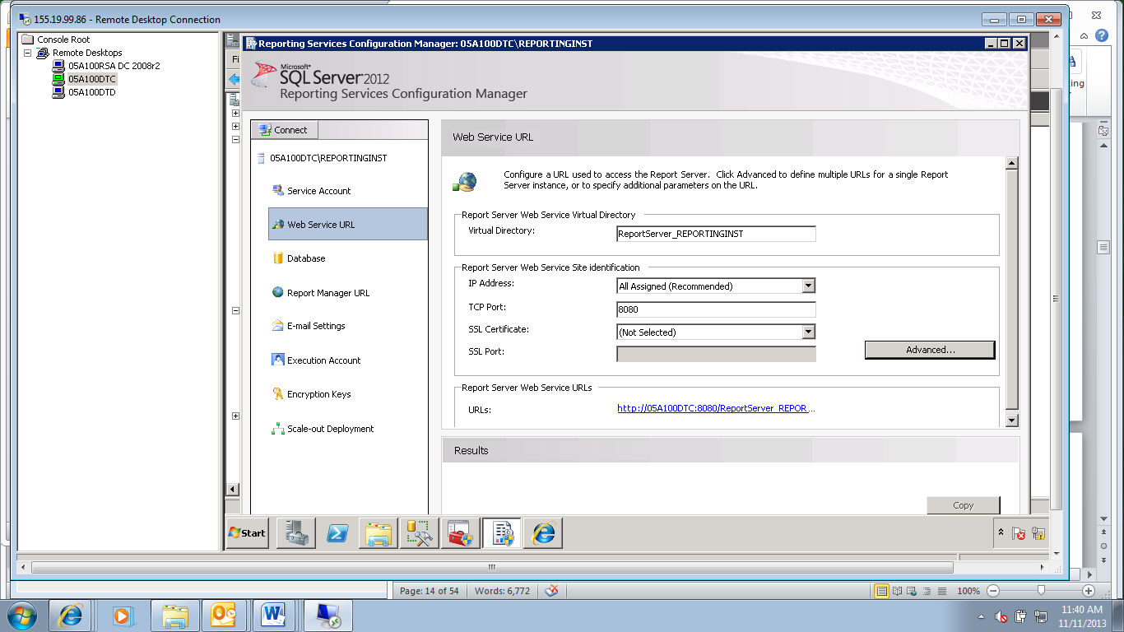

1. Click the “Apply” button. The Web Service URL is now set.

### Report Manager URL

1. Back in the SSRS Configuration Manager

* Click on the “Report Manager URL” link on the left.

1. In the “Virtual Directory:” textbox, set the virtual directory to a unique name for the server.

* It will create the URL from the information in the web service url and the unique name from the textbox.

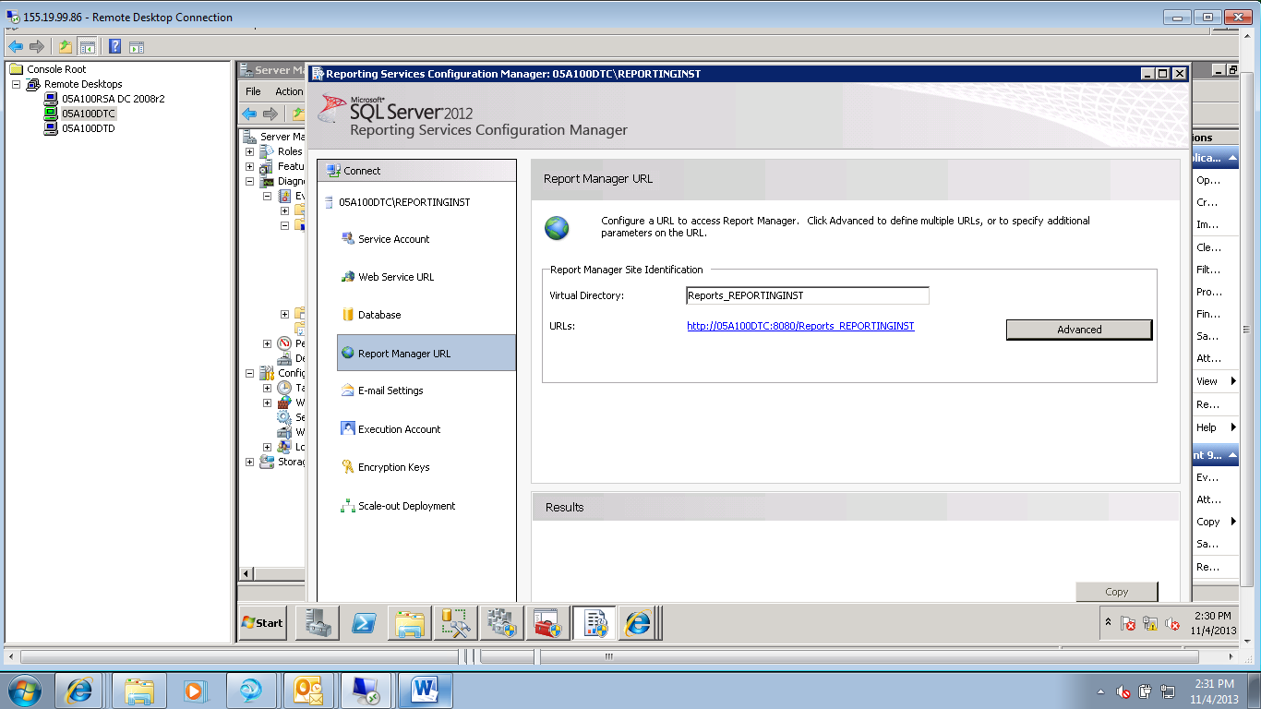

* Click the “Apply” button. The URL will be set for the server.

### E-mail Settings

NOTE: This is not typically set for reporting services at DODIG. Instructions will be provided at a later point in time, on an as needed basis for any email requirements.

“Reporting Services provides an e-mail delivery extension that allows users to subscribe to reports that are subsequently delivered to electronic mailboxes. The Report Server E-mail delivery extension must be configured before you can use it.”

1. Click on the “E-mail Settings” link in the “Connect” column,.

* Leave the fields at their default blank.

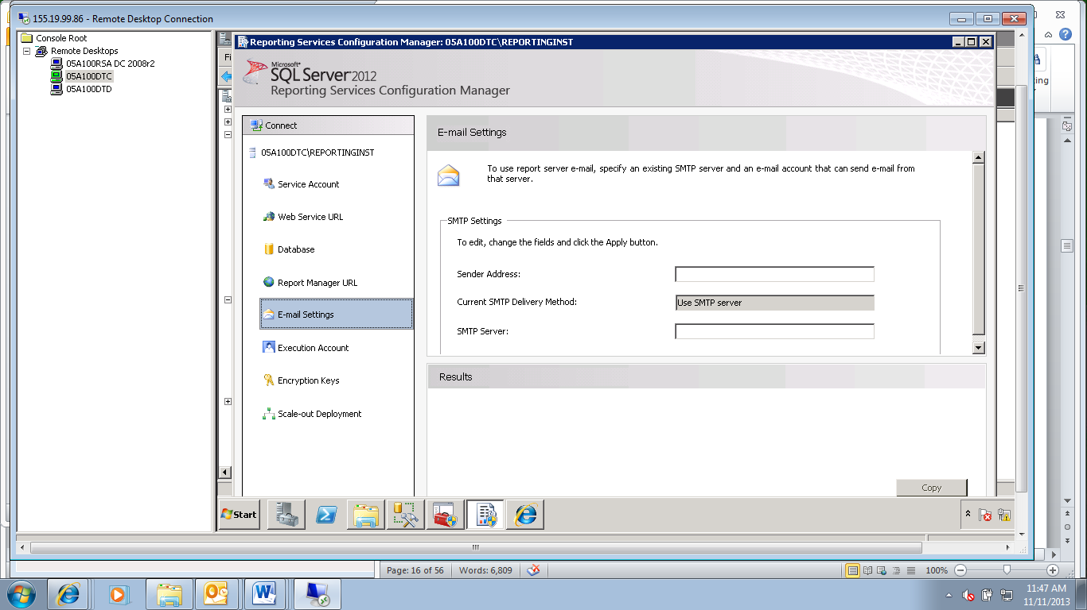

From: How to: Configure a Report Server for E-mail Delivery (Reporting Services Configuration): <http://technet.microsoft.com/en-us/library/ms345234(v=SQL.105).aspx>

### Execution Account

NOTE: This is not typically set for reporting services at DODIG. Instructions will be provided at a later point in time, on an as needed basis for any unattended execution account requirements.

“Unattended report processing refers to any report execution process that is triggered by an event (either a schedule-driven event or data refresh event) rather than a user request. The report server uses the unattended report processing account to log on to the computer that hosts the external data source. This account is necessary because the credentials of the Report Server service account are never used to connect to other computers.”

From: Configure the Unattended Execution Account: <http://technet.microsoft.com/en-us/library/ms156302.aspx>

1. Click on the “Execution Account” link in the “Connect” column,.

* Leave the fields at their default blank.

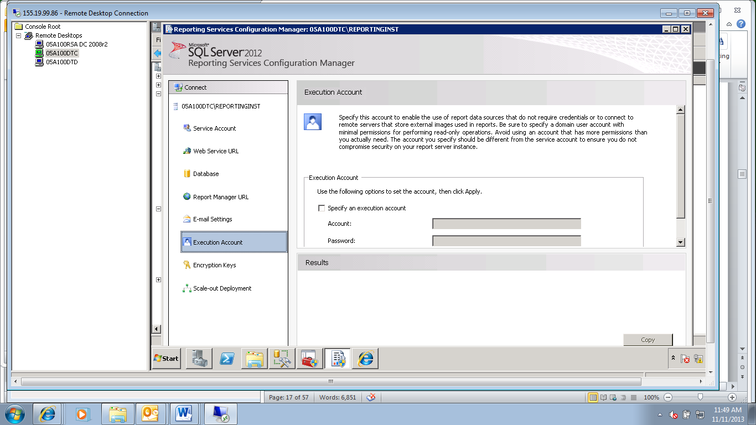

### Encryption Keys

1. Backup the Encryption Keys

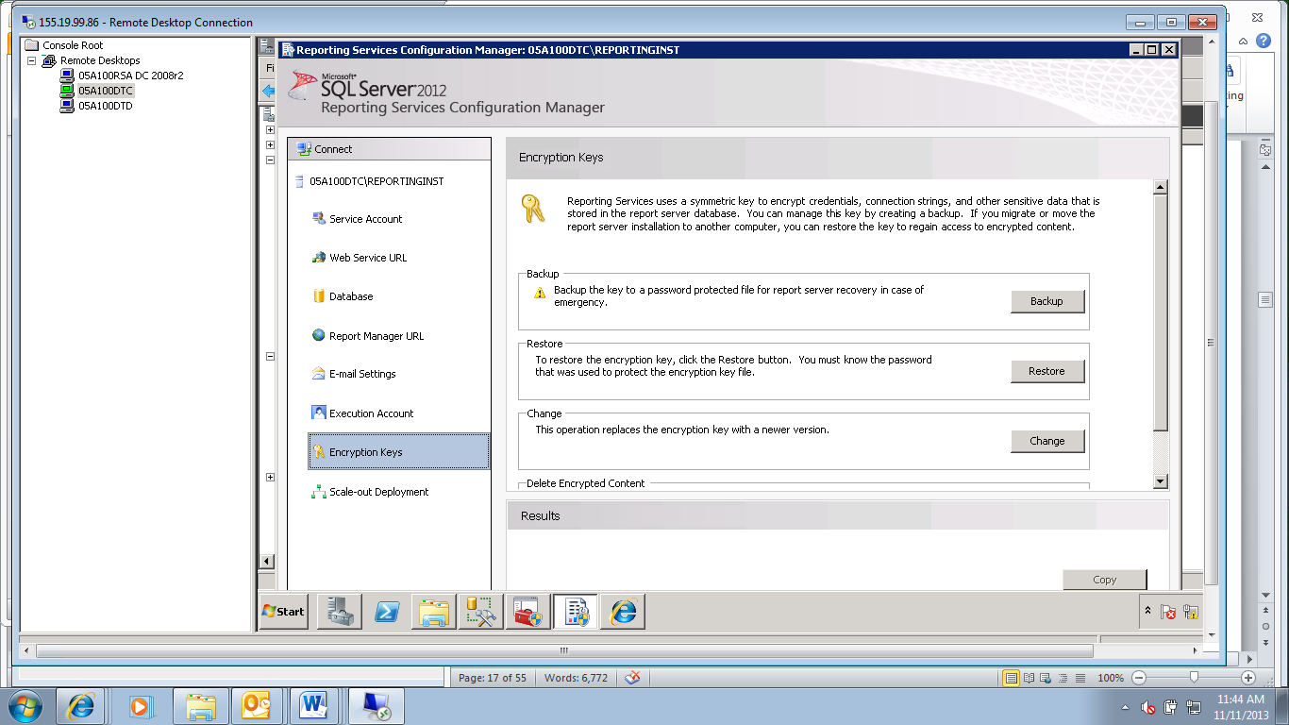

* In the “Backup” section, click the “Backup” button. The “Backup Encryption Key” box will pop up.
* Browse to the file location to store the encryption key in by clicking on the “…” button after the “File Location” textbox.

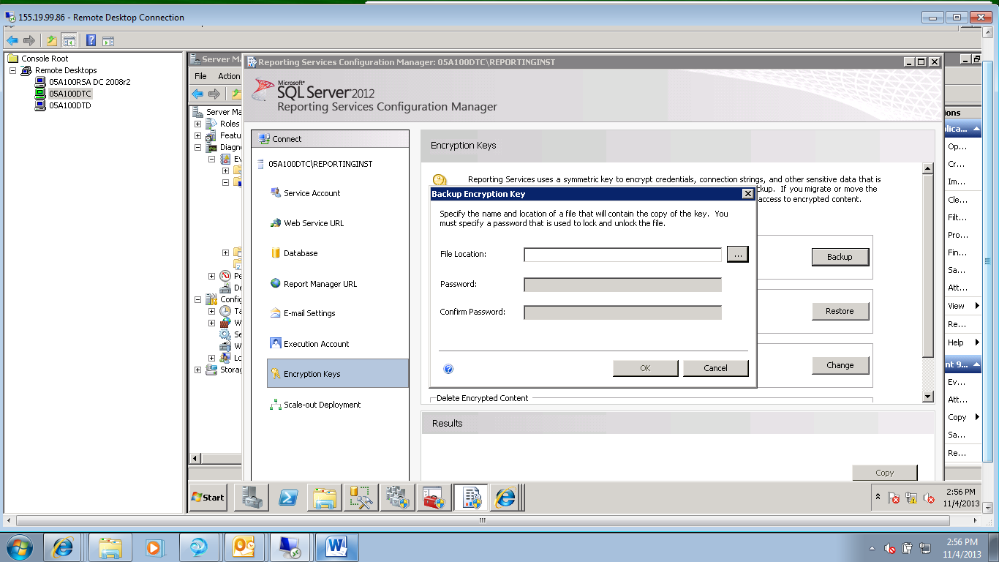

* At DODIG, the encryption key will be stored in the LogFiles directory at the following directory path: C:\Program Files\Microsoft SQL Server\MSRS11.MSSQLSERVER\Reporting Services\LogFiles\SSRS Encryption Key REPORTINGINST 20131104.snk
* Type in the password and confirm it in the “Password” and “Confirm Password:” textboxes.

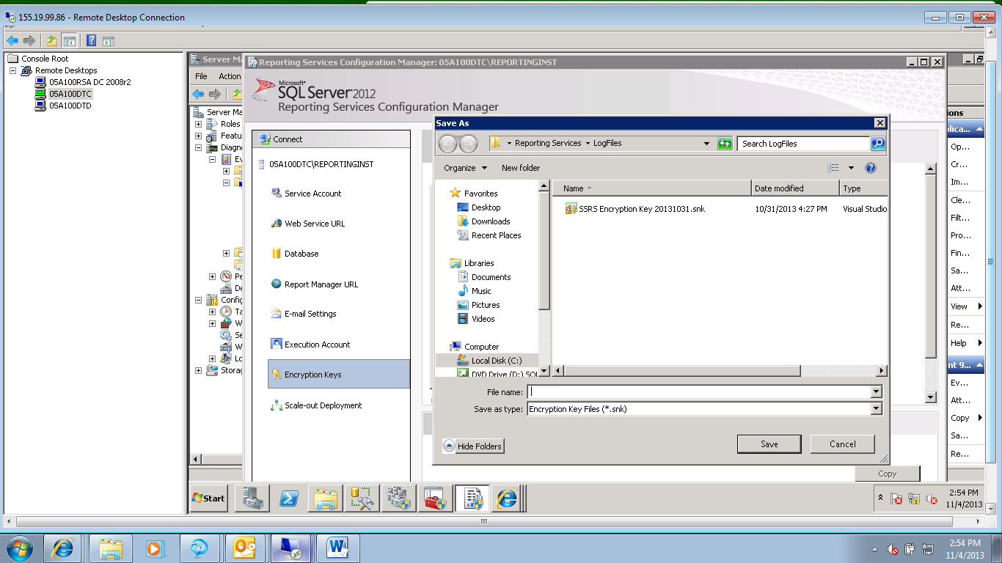

* Click “OK” to accept.
* The Encryption key will be backed up to the directory.

### Scale-out Deployment

NOTE: This is typically set for load balanced reporting services at DODIG. Instructions will be provided for setting up load balanced servers later in the document. For a single SSRS installation this section will look like the example below. No further configuration is required.

“Reporting Services native mode supports a scale-out deployment model that allows you to run multiple report server instances that share a single report server database. Scale-out deployments are used to increase scalability of report servers to handle more concurrent users and larger report execution loads. It can also be used to dedicate specific servers to process interactive or scheduled reports”

1. Click on the “Scale-out Deployment” link in the Connect column.

* You will see the screen below which is already configured for the current server.
* The current server has a status of “Joined”.

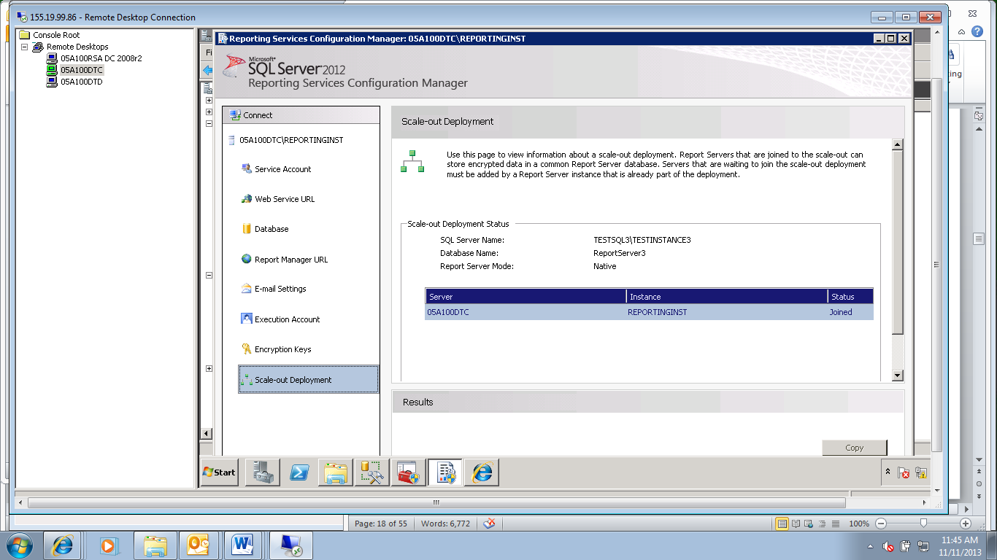

From: Configure a Native Mode Reporting Server Scale Out Deployment: <http://technet.microsoft.com/en-us/library/ms159114.aspx>

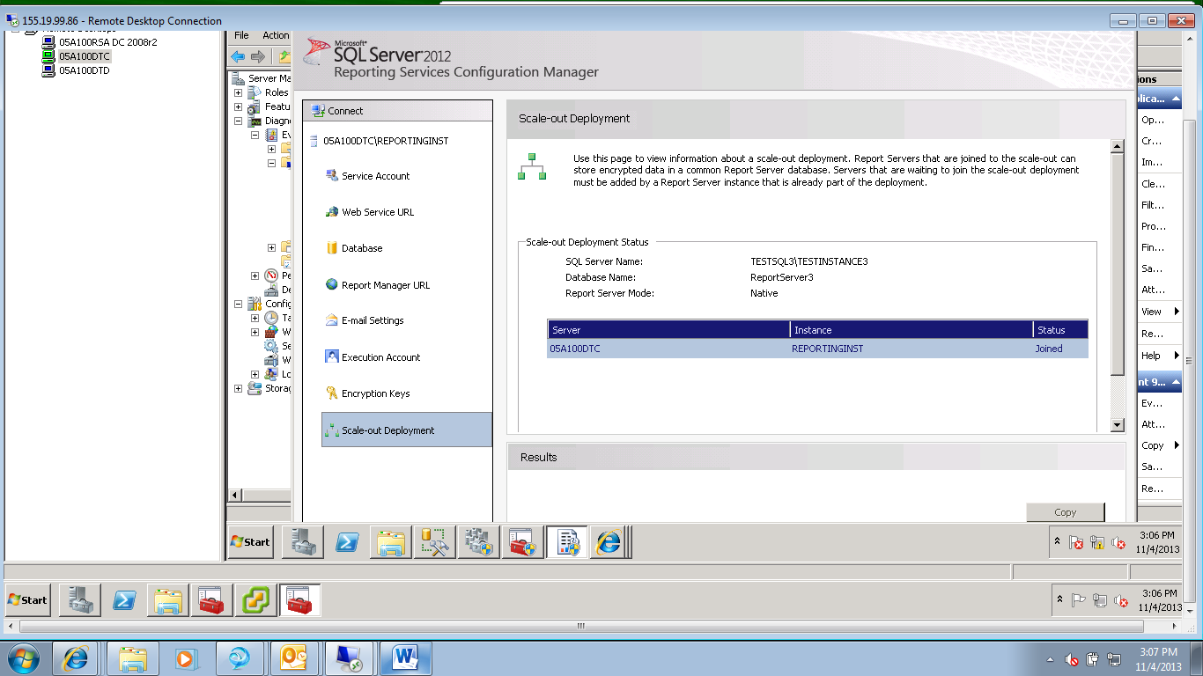

## Procedure to Set HTTPS

NOTE: This must be done for the SQL instance that houses the reporting services databases.

NOTE: Steps for setting SPN’s for the SQL instance can be found in the SQL2K12 SPN document.

### Install a Certificate for SSL

1. Install an SSL certificate on the SSRS server.

* Please see the document “SQL2K12_SSL-Certificate” for instructions.

### To configure a report server URL for SSL

1. From the Reporting Services Configuration tool that was opened above

* Connect to the report server as instructed above.

1. Click Web Service URL link in the “Connect” column.

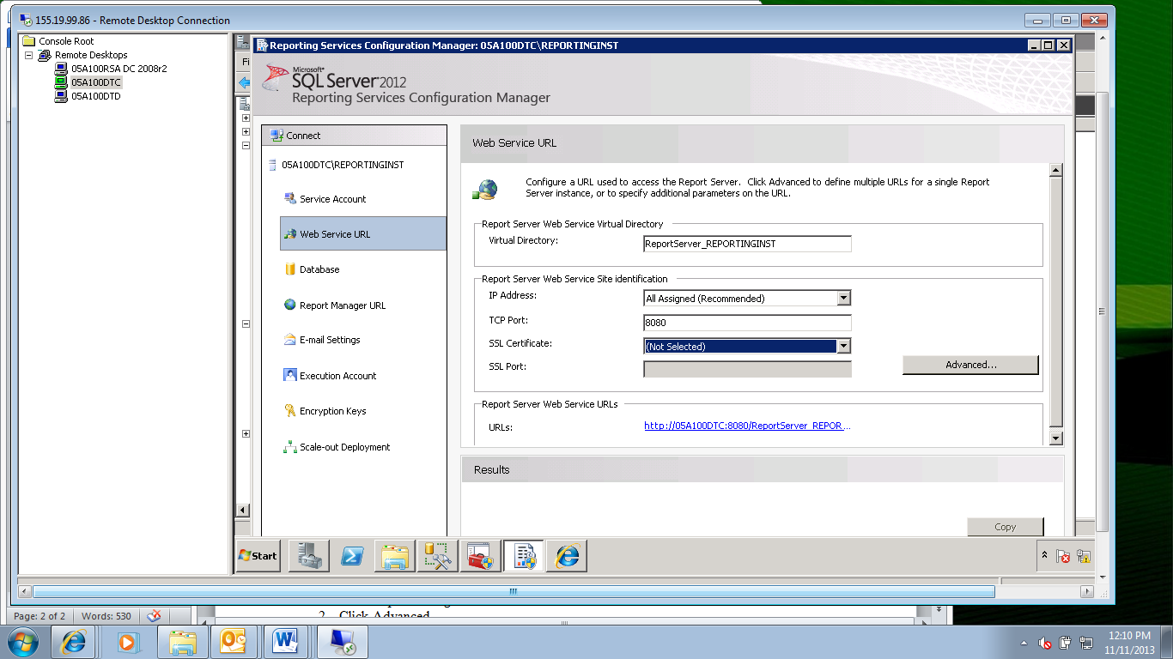

* In the drop-down box after the “SSL Certificate” title, expand the certificate list for the SSRS server.

NOTE: If the certificate is not visible review the instructions in the “SQL2K12_SSL-Certificate” document.

NOTE: Reporting Services detects server authentication certificates in the local store. If you installed a certificate and you do not see it in the list, you might need to restart the service.

NOTE: You can use the Stop and Start buttons on the Report Server Status page in the Reporting Services Configuration tool to restart the service.

* Select the certificate.
* Click Apply.
* Click the URL to verify it works. It should open successfully in the browser.

### To configure the reports URL for SSL

NOTE: URL reservations for Report Manager and the Report Server Web service are configured independently. If you need to configure Report Manager access through an SSL-encrypted channel, continue with the following steps:

1. From the Reporting Services Configuration tool that was opened above

* Connect to the report server as instructed above.

1. Click “Report Manager URL” link in the “Connect” column.

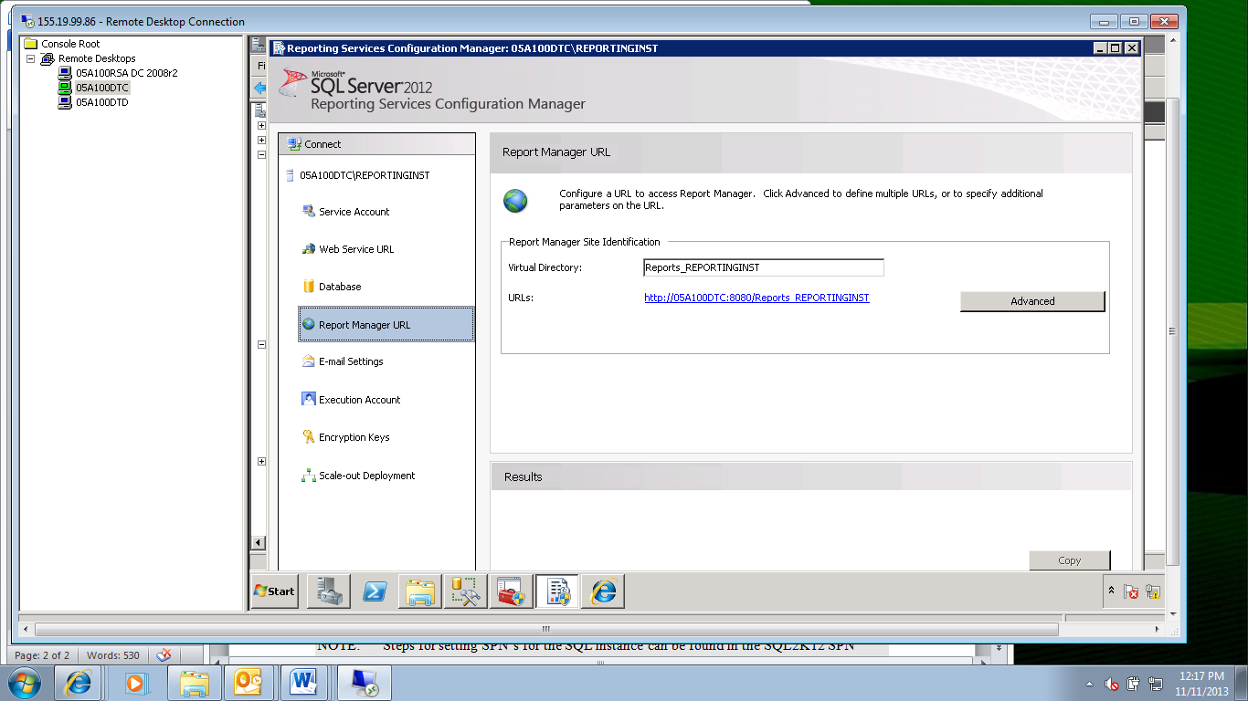

* Click Advanced.
* The “Advanced Multiple Web Site Configuration” pop-up box will open.

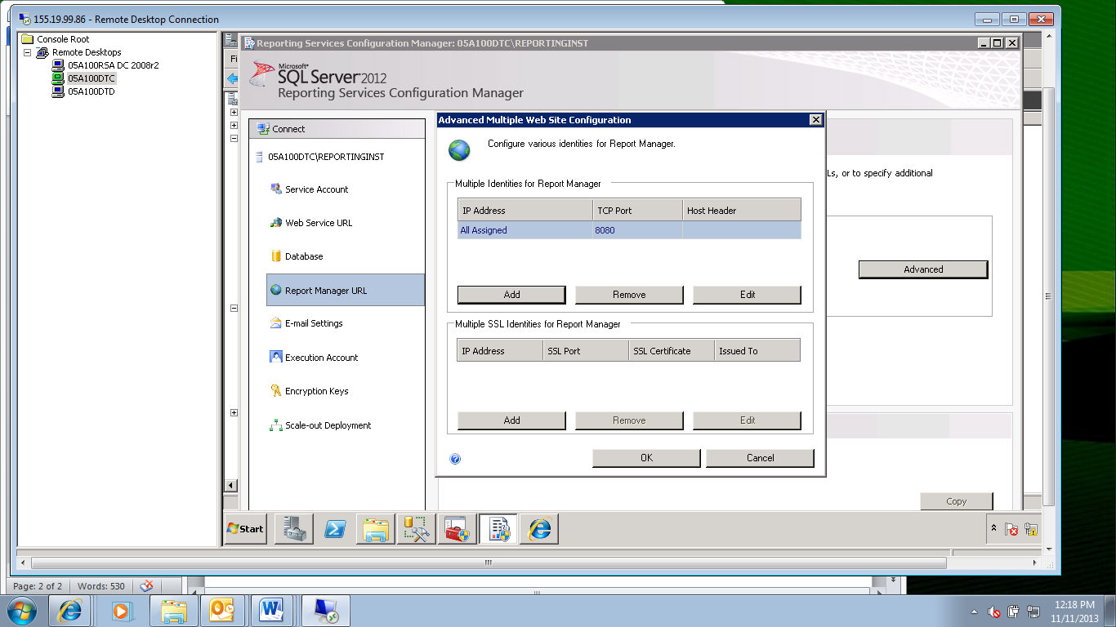

* In the “Multiple SSL Identities for Report Manager” section, click Add.
* The “Add a Report Manager SSL Binding” window will appear.

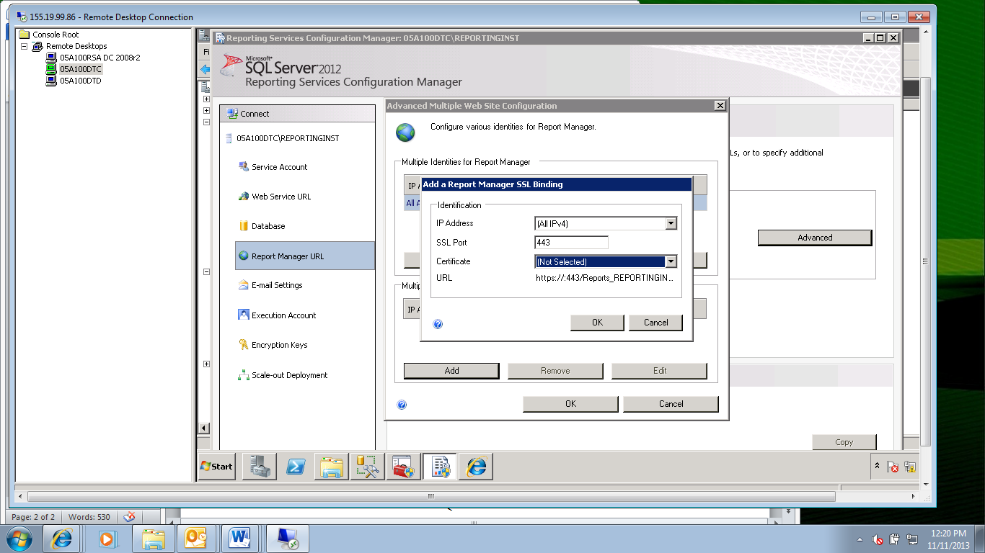

* After “Certificate:”, select the certificate from the drop-down box
* Click OK
* Click Apply.
* Click the URL to verify it works. It will open successfully in a browser window.

## Procedure to Set SPN’s for the SQL Service Account Using TCP/IP

NOTE: This must be done for the SQL instance that houses the reporting services databases.

NOTE: Steps for setting SPN’s for the SQL instance can be found in the SQL2K12 SPN document.

1. The SPN’s must be set on the instance housing the reporting databases or the double hop will not work and Kerberos will not work for SSRS.

* Please refer to the “SQL2K12 SPN Creation Guide.docx”.

## Procedure to Set SPN’s for the SQL Reporting Server Service Account

NOTE: This must be done for the SQL instance that houses the SSRS service.

NOTE: Steps for setting SPN’s for the SSRS service instance can be found in the SQL2K12 SPN document.

1. The SPN’s must be set on the SSRS instance or the double hop will not work and Kerberos will not work for SSRS.

* Please refer to the “SQL2K12 SPN Creation Guide.docx”.

## Procedure to Set the Configuration file to enable NTLM

NOTE: SSRS must be configured to enable NTLM or Kerberos so that the SPNs can work and Kerberos is enabled. This is done by editing the configuration file.

NOTE: This must be done for the SSRS instance.

NOTE: Steps for editing the configuration file for the SSRS instance can be found in the SQL2K12 SPN document.

1. The SSRS configuration must be edited on the SSRS instance to enable Kerberos for SSRS.

* Please refer to the “SQL2K12 SPN Creation Guide.docx”.

## Procedure to Set SPN’s for the SQL Reporting Server Service Account using AD

NOTE: This is an alternative method to editing the configuration file for the SSRS instance, and edits the Active Directory record directly. Instructions for using this method can be found in the SQL2K12 SPN document.

1. The AD record for the service account running the SSRS instance can be edited directly to enable Kerberos for SSRS.

* Please refer to the “SQL2K12 SPN Creation Guide.docx”.

## Procedure to check the browser settings

NOTE: Kerberos will not work unless the non-fully qualified SSRS website is added to the Local Intranet zone. The steps to do this are described below.

NOTE: This step will prevent a login pop-up box from appearing when you go to a reporting services URL.

1. Open Internet Explorer (I.E.) on the Client server.

* Log onto a server from which you want to connect to the SSRS website.
* Open Internet Explorer by clicking on “Start”, then on “All Programs”, and finally on “Internet Explorer”.
* I.E. will open.

1. Access the menu in I.E.

* Click anywhere inside of I.E.
* Click the “Alt” key on your keyboard.
* The menu along the top of I.E. will appear.

1. Open the Internet Options in I.E.

* Click on the “Tools” menu to open.
* Click on “Internet Options” from the context menu.
* The “Internet Options” page will pop up.

1. Set the Security Settings

* Click on the “Security” tab.
* Click on the “Local Intranet” icon to highlight.
* Click on the “Sites” button.
* The “Local Intranet” page will pop up.

1. Edit the local intranet settings.

* In the “Add this website to the zone:” textbox, type the name of the SSRS server:

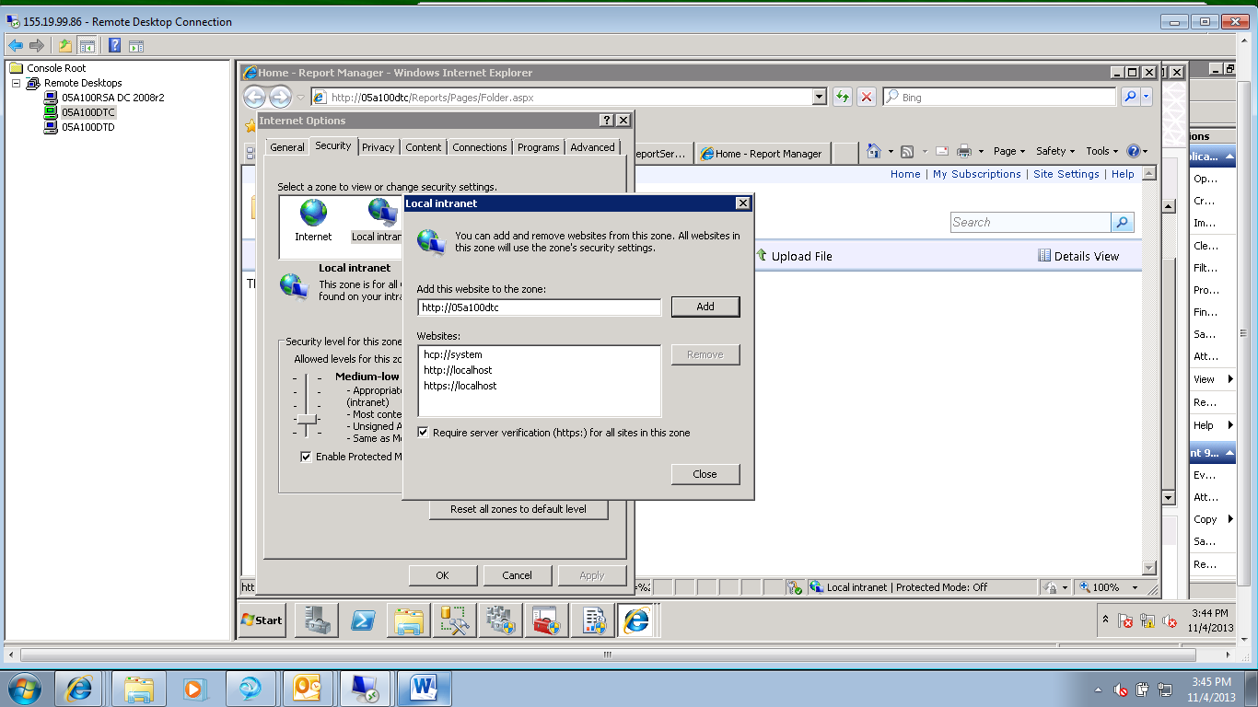

* Uncheck the “Require server verification (https☺ for all sites in this zone.
* Click the “Add” button. The url will be added to the “Websites” textbox.
* Click the “Close” button.
* For example:

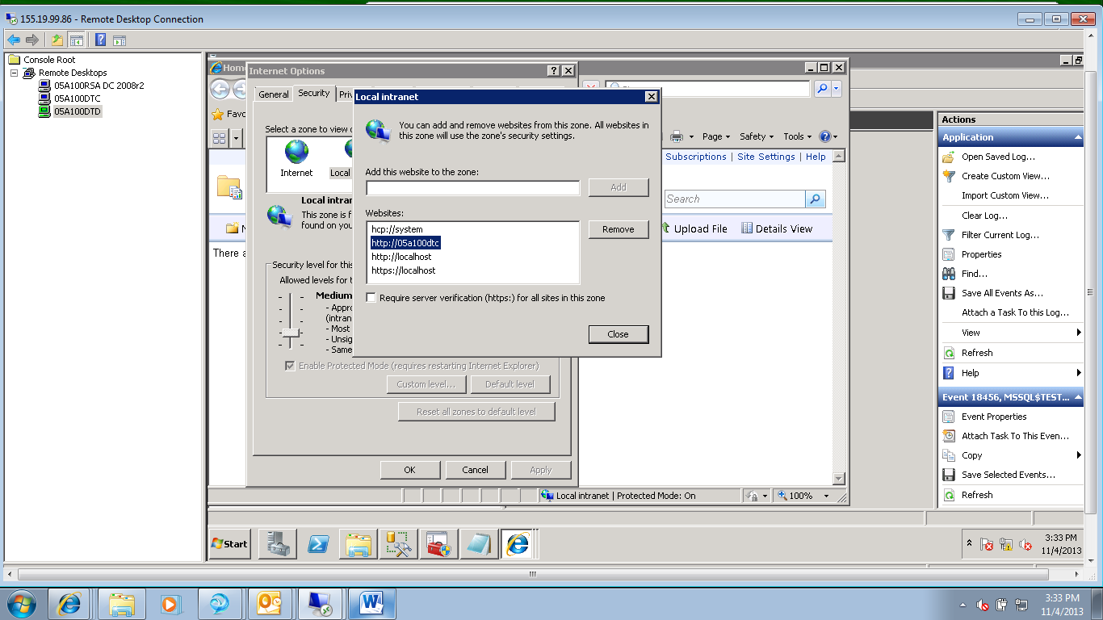

* Click the “OK” button.

## Procedure to Set Trusted for Delegation on the SSRS server

NOTE: This is set once for the server that is running the SSRS service. Once it is set, as many SSRS instances as required can be installed on the server.

NOTE: Each SSRS instance will have a separate port for Kerberos to work.

1. Open up Active Directory Users and Computers.

* Use an account with Administrator privileges.

1. Locate the SSRS server

* At DoDIG this is under Servers/Mark Center/SQLPROD

1. Open the properties for the server.

* Right click on the server and choose “Properties” from the context menu.
* The “Properties” box will open.

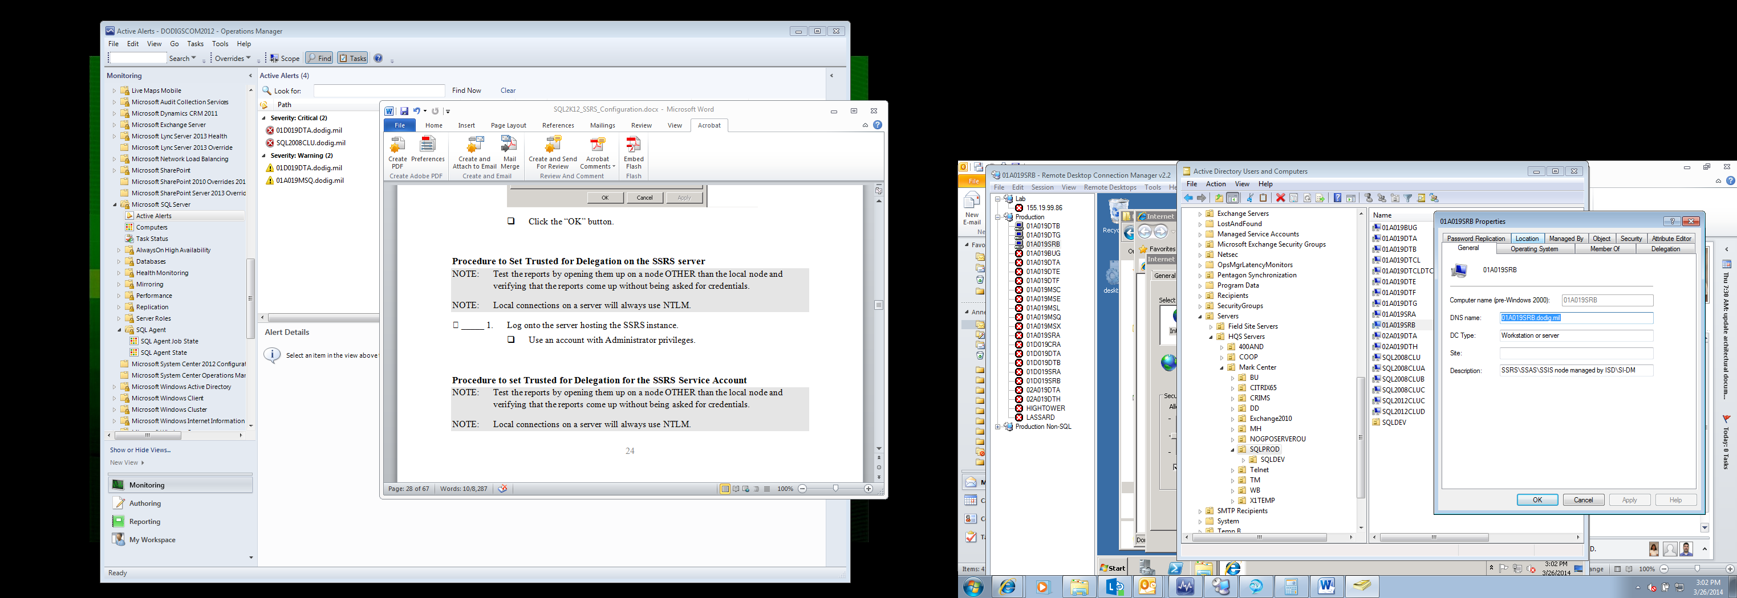

1. Trust this computer for delegation

* Click on the “Delegation” tab.
* Choose “Trust this computer for delegation to any service (Kerberos only)” under “Delegation is a security-sensitive operation, which allows services to act on behalf of another user.
* Click “OK” to accept.

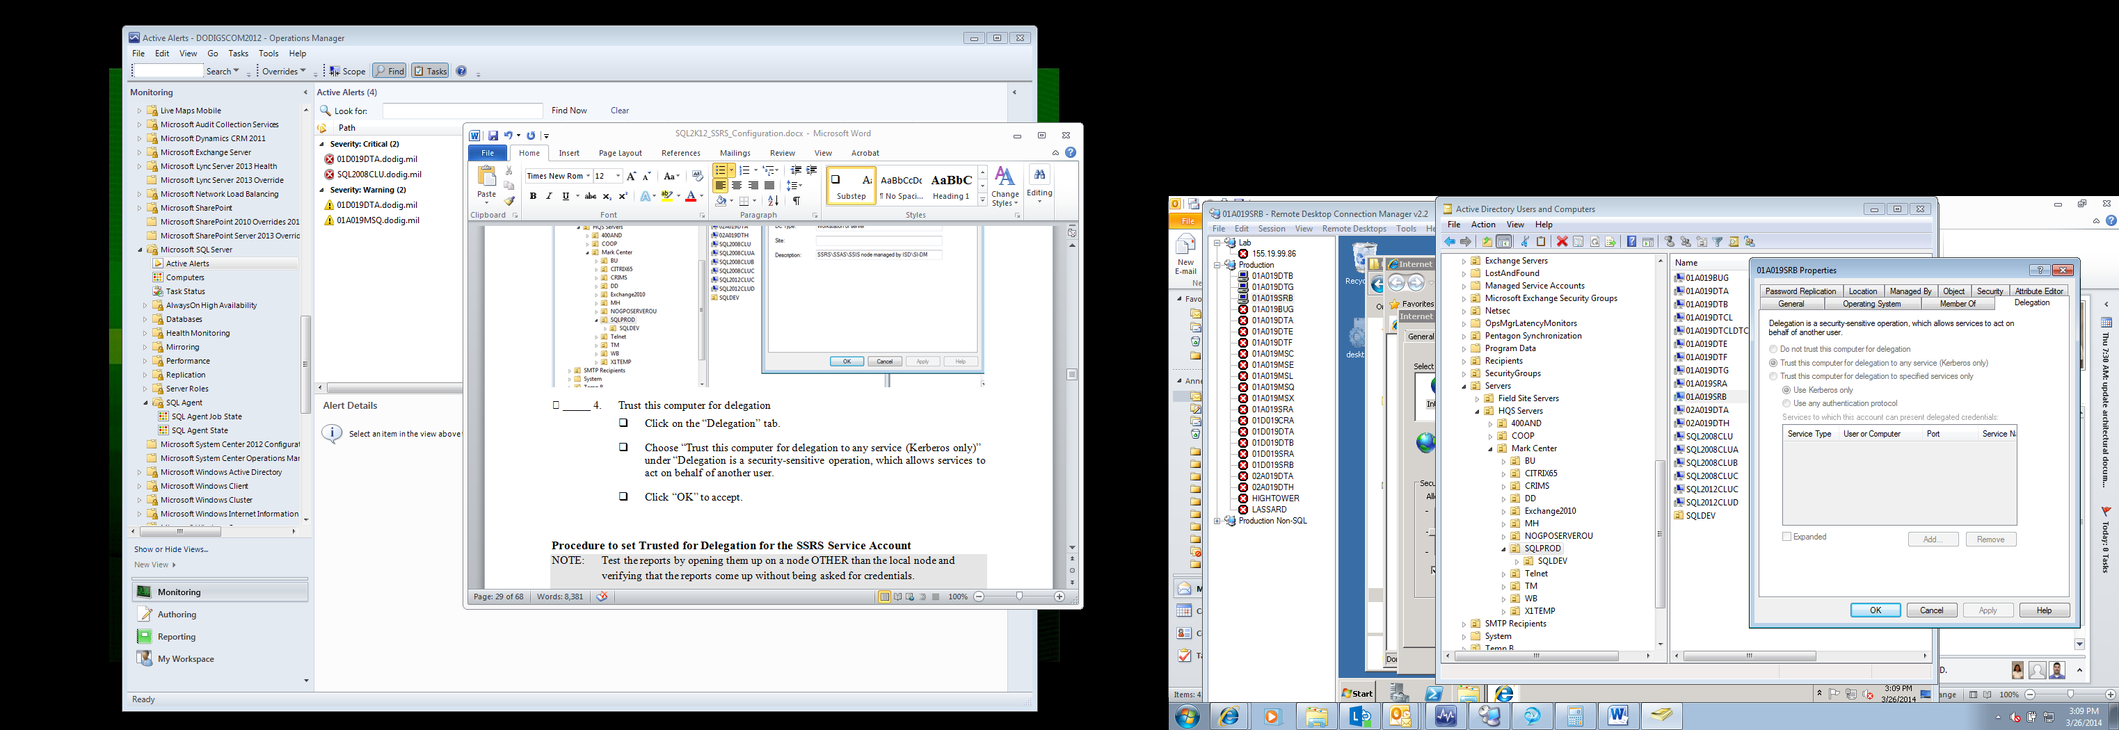

## Procedure to set Trusted for Delegation for the SSRS Service Account

NOTE: This is set once for each instance on the server that is running the SSRS service. This is set on the domain user service account that the SSRS Service is running under.

NOTE: Each SSRS instance will have a separate service account.

1. Open up Active Directory Users and Computers.

* Use an account with Administrator privileges.

1. Locate the SSRS service account

* At DoDIG this is under DomainAccounts/ServiceAccounts/SQL2012

1. Open the properties for the service account.

* Right click on the server and choose “Properties” from the context menu.
* The “Properties” box will open.

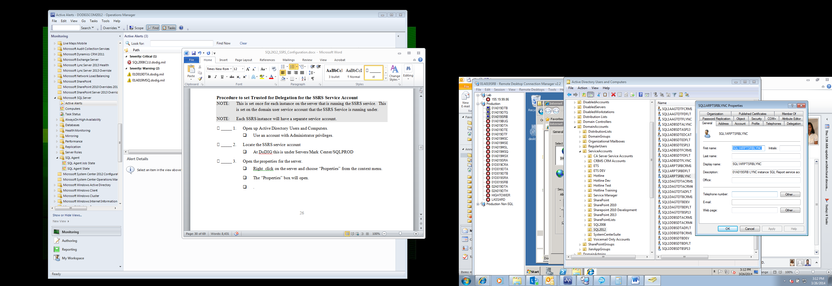

1. Trust this account for delegation

* Click on the “Delegation” tab.
* Choose “Trust this user for delegation to any service (Kerberos only)” under “Delegation is a security-sensitive operation, which allows services to act on behalf of another user.
* Click “OK” to accept.

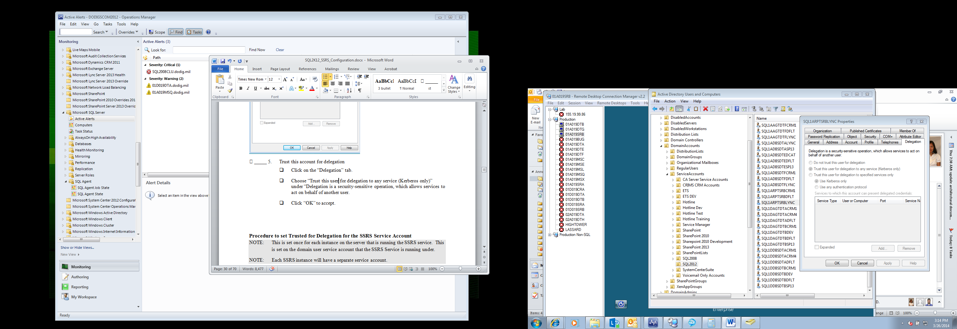

## Run all software as Administrator

NOTE: This is a helpful hint if you are having trouble getting some of the steps above to work.

NOTE: This applies to I.E., SSRS Manaager, etc.

1. Run SSRS manager as Administrator.

* Use an account with Administrator privileges.
* Make sure you are choosing the SSRS software for the version you are using. In other words if you are trying to open a SQL 2012 instance, use the “SQL 2012 Reporting Services Configuration Manager” software.
* Ensure this by opening the software up under the “Microsoft SQL Server 2012” node.

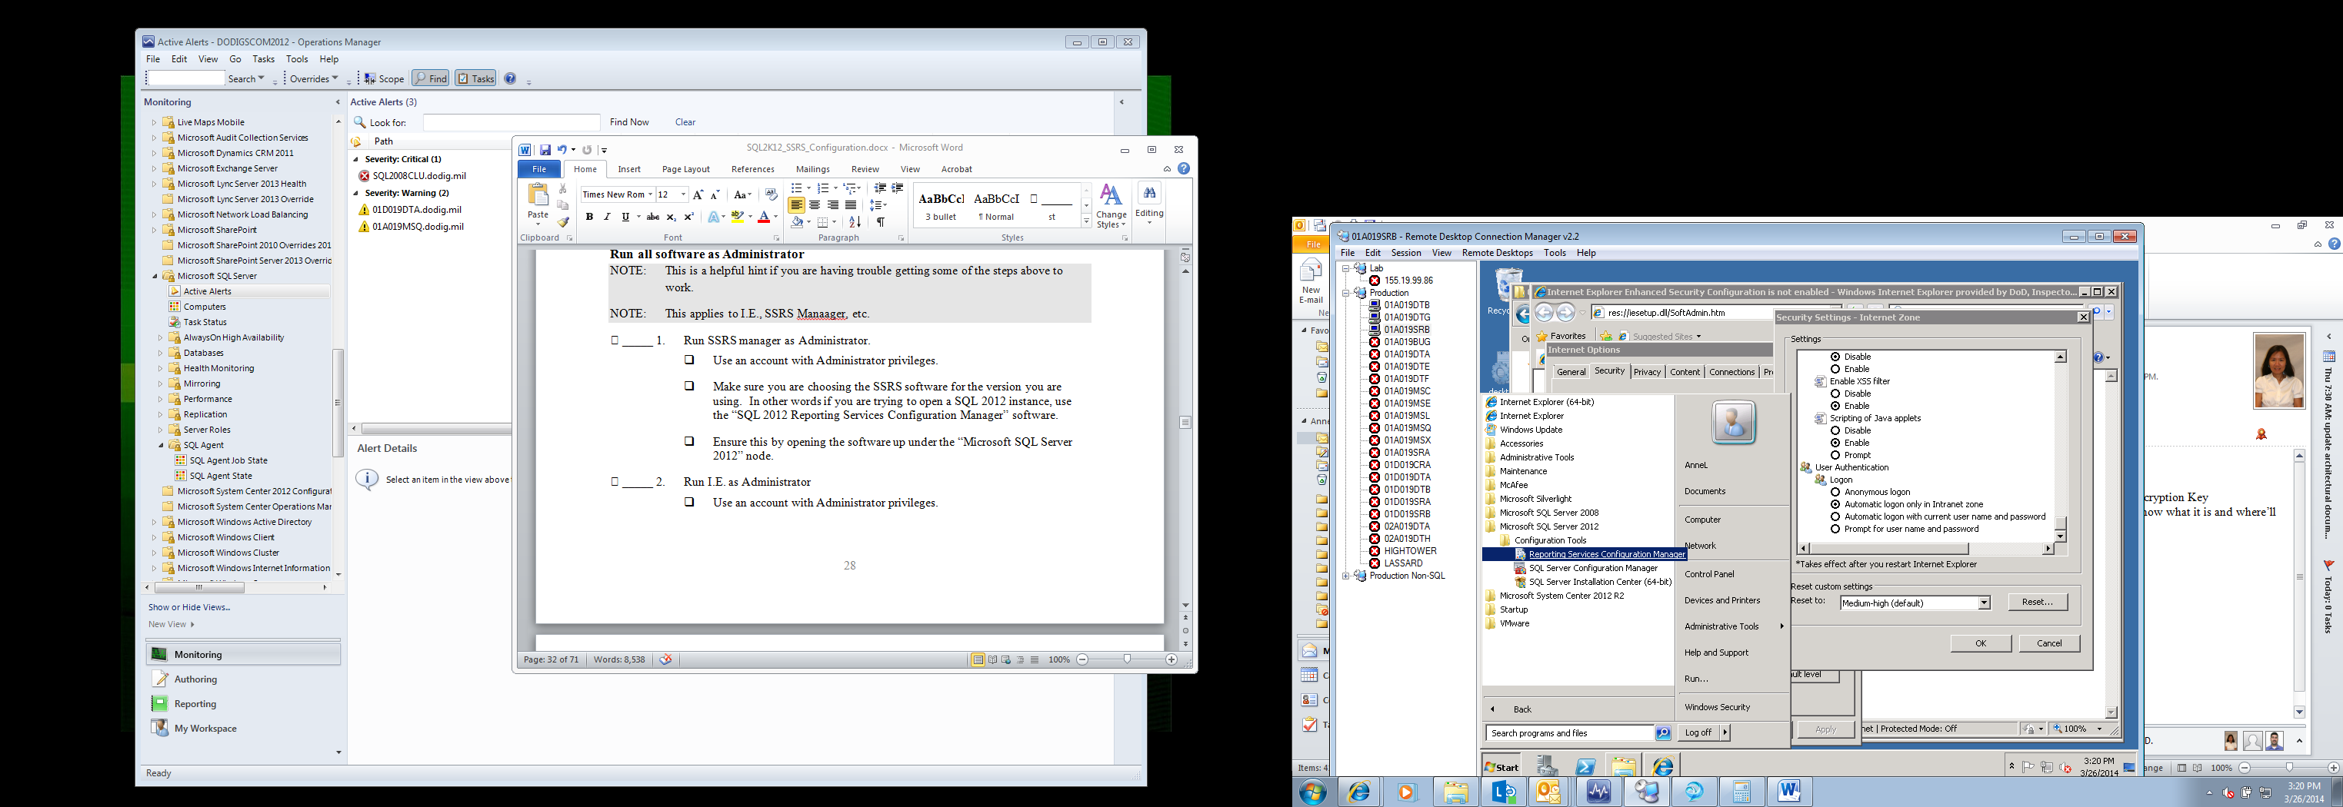

1. Run I.E. as Administrator

* Use an account with Administrator privileges.
* Right click on I.E. and choose “Run as Administrator” from the context menu.

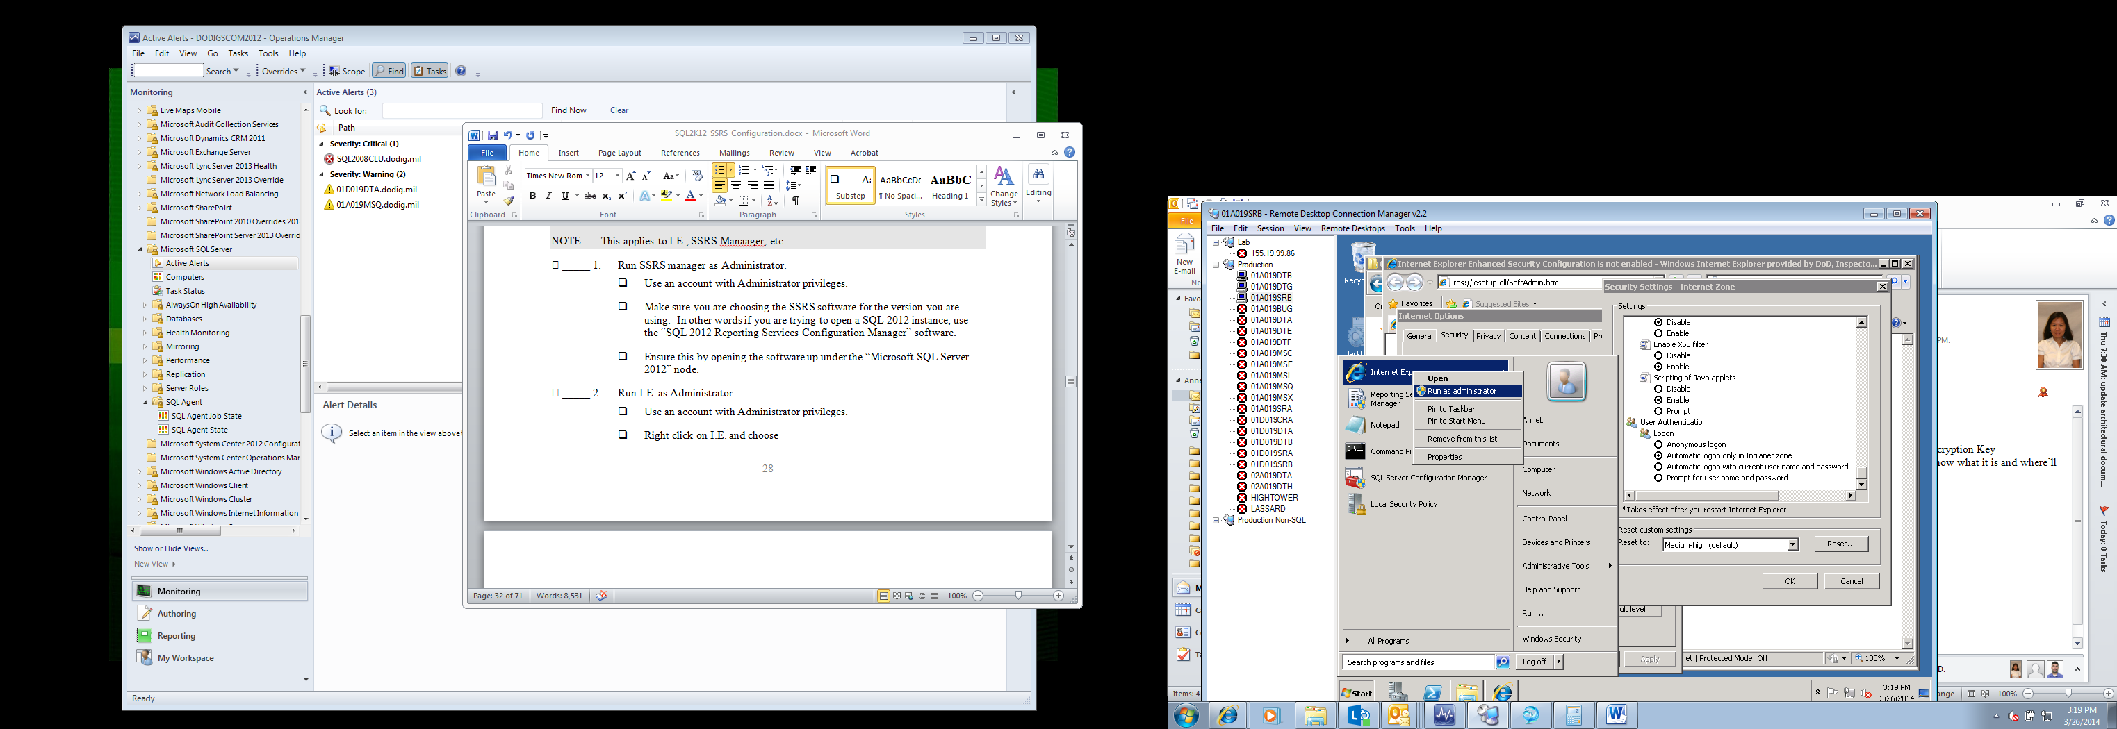

## Use the 64 bit edition of I.E

NOTE: This is a helpful hint if you are having trouble getting some of the steps above to work. I ran into this problem during a particularly difficult installation.

1. Open the 64 bit version of I.E.

* Run I.E. as Administrator
* From exploring, Browse to “Program Files” (NOT Program Files (x86))

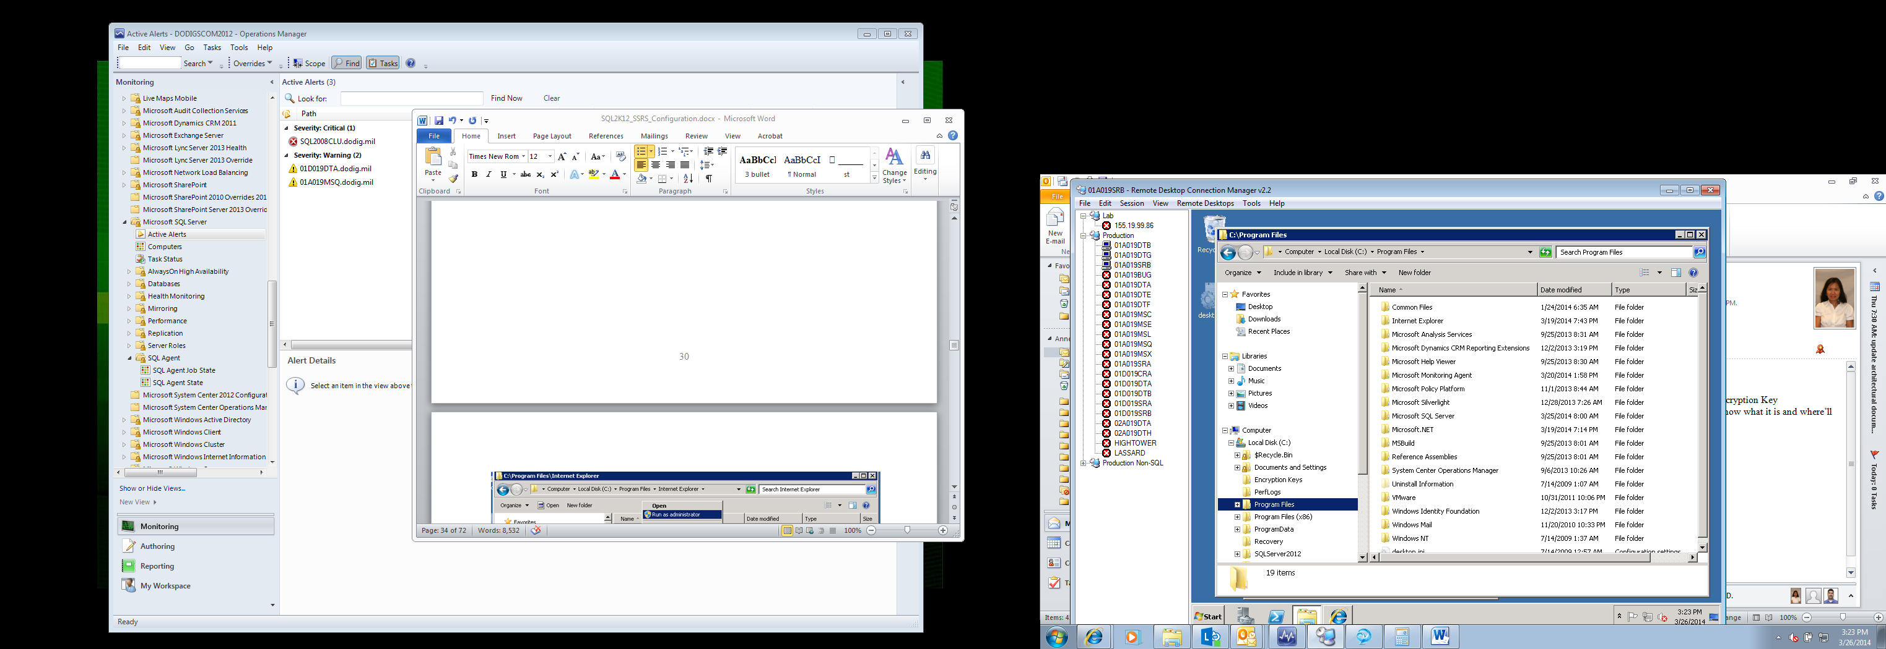

* Open the “Internet Explorer” node, right click on “iexplore.exe” and choose “Run as Administrator” from the context menu.

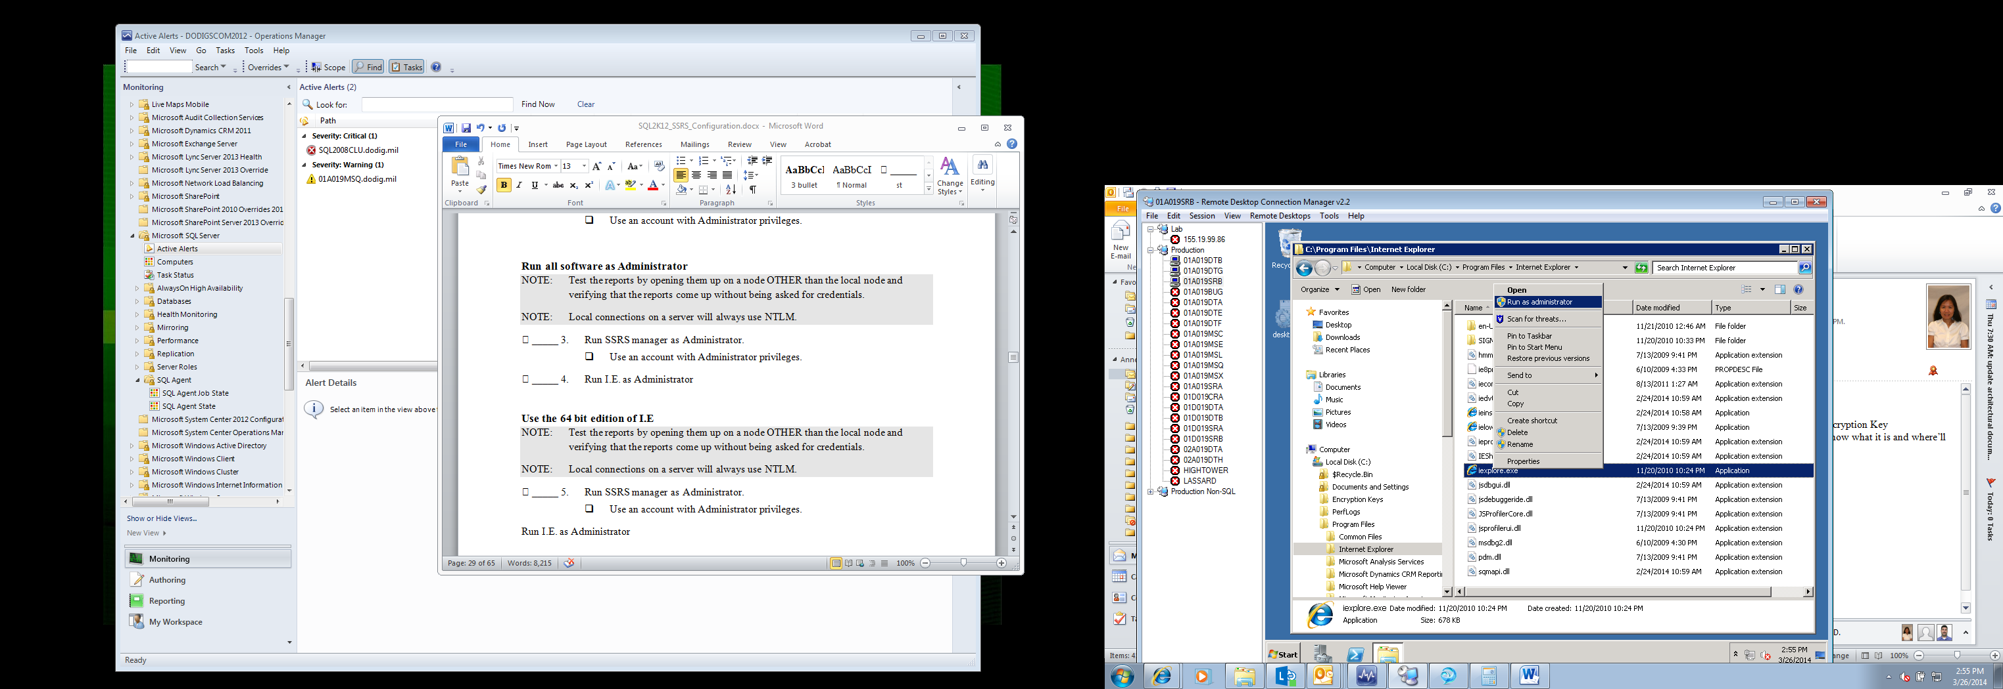

* When the “User Account Control” box pops up click “Yes”.

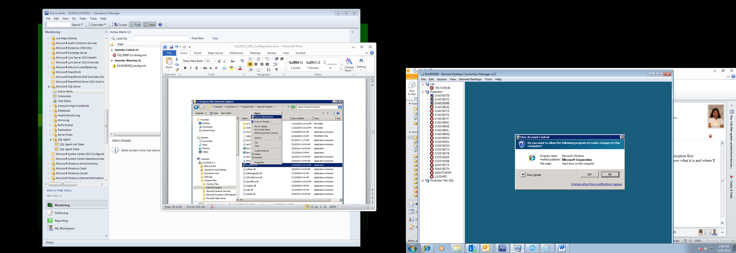

* The browser will open.

## Set I.E to automatically log on with username and password

NOTE: This needs to be done once on the server.

NOTE: Do this step if you are having trouble with getting authentication for the SSRS url to work without having to manually log in.

1. Open I.E. 64 bit (instructions provided above).

* Use an account with Administrator privileges.
* Run I.E. as Administrator

1. Open up “Internet Options”.

* Click on “Tools” then “Internet Options”.

NOTE: If the Tools menu is not visible click the “Alt” key.

1. Add the url to trusted sites

* Click on the “Security” tab to open.
* Click on “Trusted Sites” in the “Select a zone to view or change security settings.” Section.
* Click on the “Sites” button.
* In the “Add this website to the zone:” textbox type in the fully qualified domain name of the server.
* Click the “Add” button.
* In the “Add this website to the zone:” textbox type in the netbios name of the server.
* Click the “Add” button.

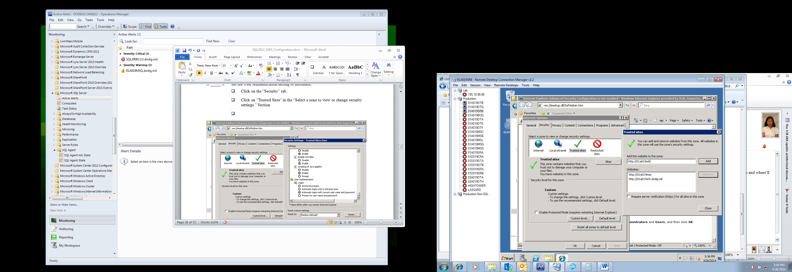

* Click “Close”

1. Set the User Authentication setting to automatic.

* From the “Security” tab.
* Click on “Trusted Sites” in the “Select a zone to view or change security settings.” Section.
* Click on the “Custom level…” button. The “Security Settings – Trusted Sites Zone” will open.
* Scroll to the bottom until you see the “User Authentication” section.
* Place a check in front of “Automatic logon with current user name and password”
* Click “OK” twice to accept.

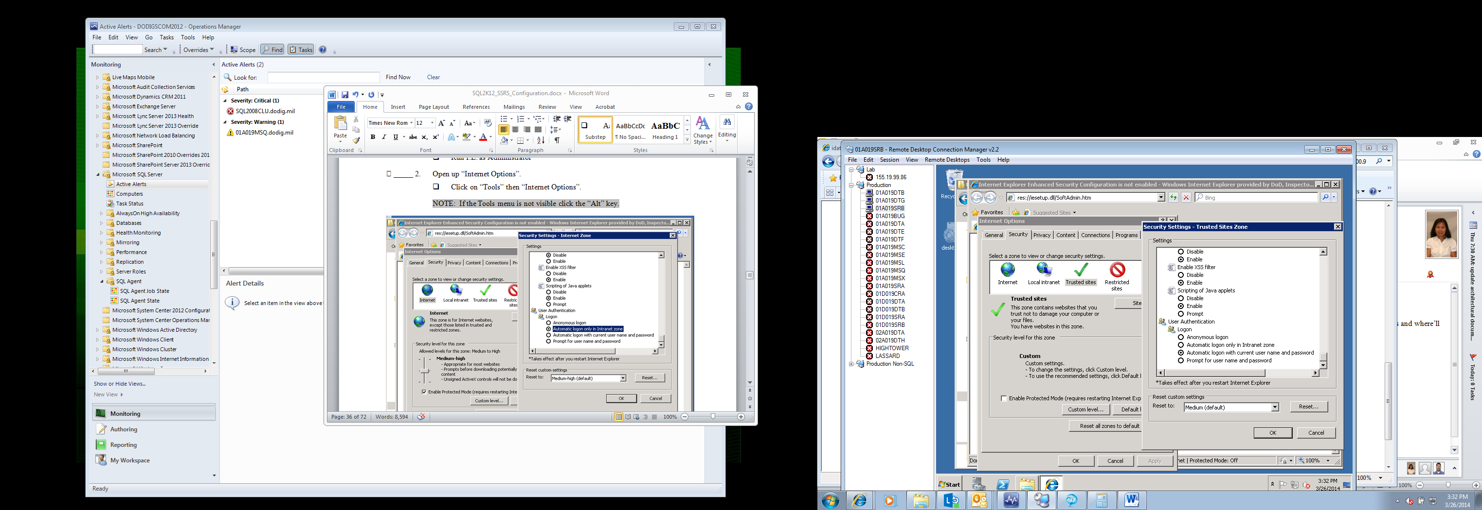

## Procedure to test the reports

NOTE: Test the reports by opening them up on a node OTHER than the local node and verifying that the reports come up without being asked for credentials.

NOTE: Local connections on a server will always use NTLM.

1. Log onto the server hosting the SSRS instance.

* Use an account with Administrator privileges.

1. Open the SSRS Manager (Reporting Services Configuration Manager)

* Click on the windows icon, then on “All Programs”, then on “Microsoft SQL Server 2012”, then on “Configuration Tools”, and lastly on “Reporting Services Configuration Manager” to open.



* The “User Account Control” box will pop up. Click “Yes” to accept.
* “Reporting Services Configuration Manager” opens

1. Connect to the reporting services instance.

* The “Reporting Services Configuration Connection” box will pop up.
* The server name should already be populated in the “Server Name:” textbox. If it is not, type it in.
* Choose the instance to configuration from the “Report Server Instance:” drop down box.
* Click the “Connect” button to connect.

1. Test the Web Service URL

* Click on the “Web Service URL” link on the left
* This will bring up the “Web Service URL” page on the right. (see screen shot below).

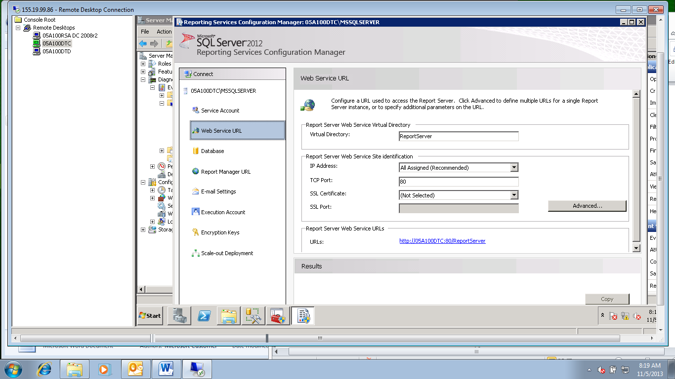

* Under “Report Server Web Service URLs” click on the “URLs:” link.
* It should bring up a browser page that looks similar to the following:

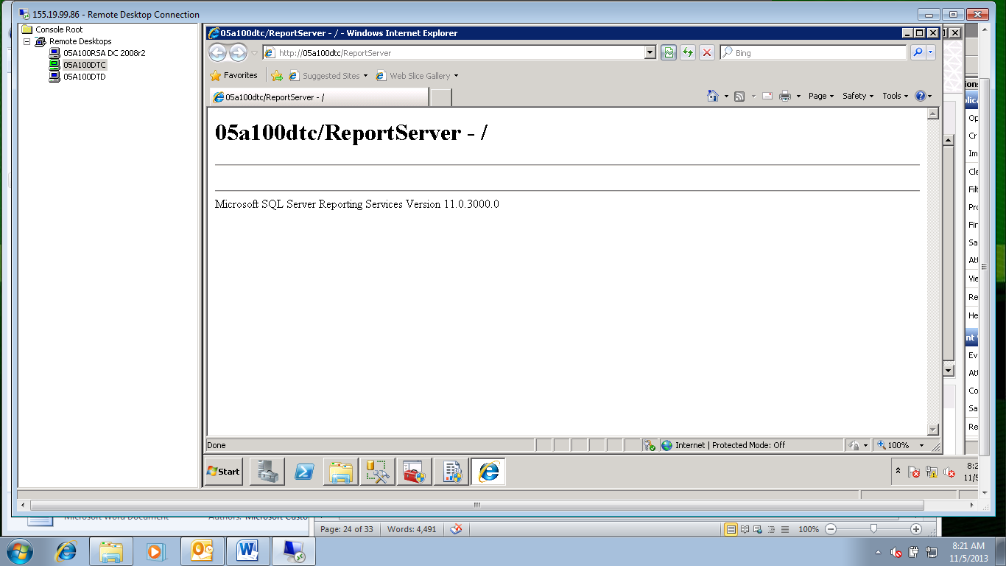

1. Test the Report Manager URL.

* Click on the “Report Manager URL” link on the left.
* The “Report Manager URL” page will open. (see screen shot below.)

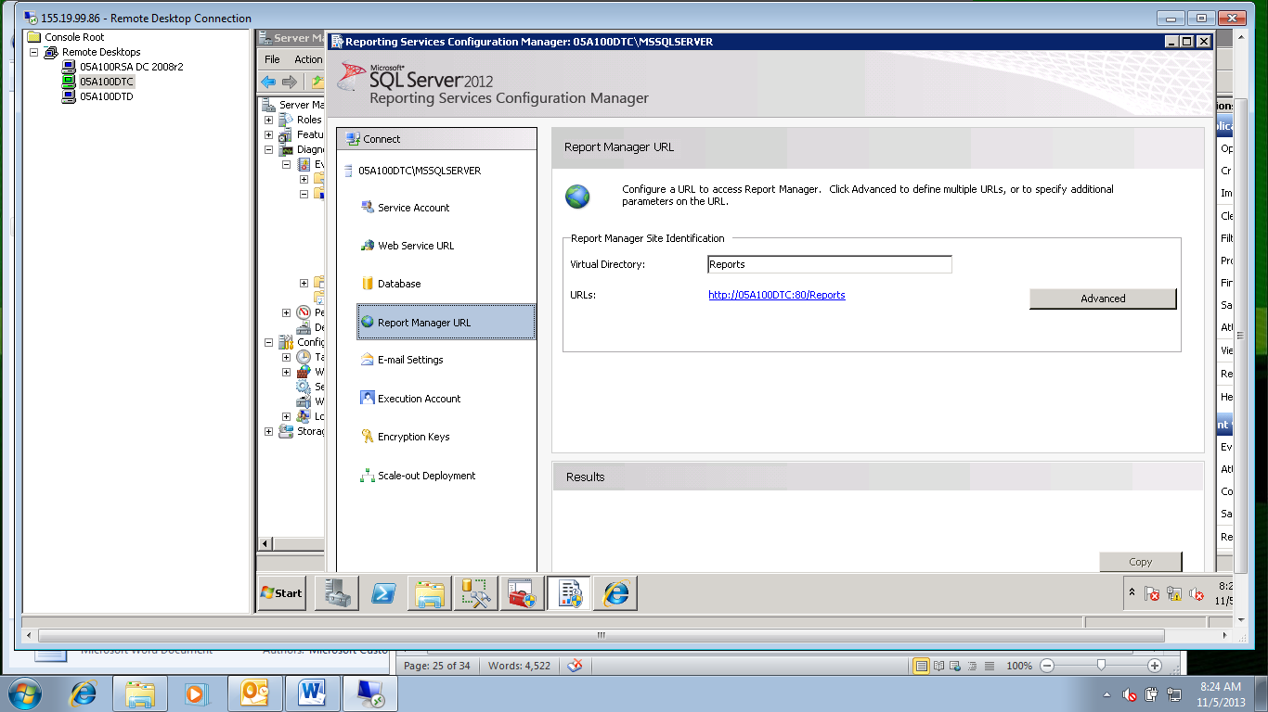

* Click on the URLs: link.
* It should bring up a browser page that looks similar to the following:
* NOTE: If an “Internet Explorer” box pops up please see instructions from previous section “Procedure to check the browser settings” above.
* The “SQL Server Reporting Services” page will open.

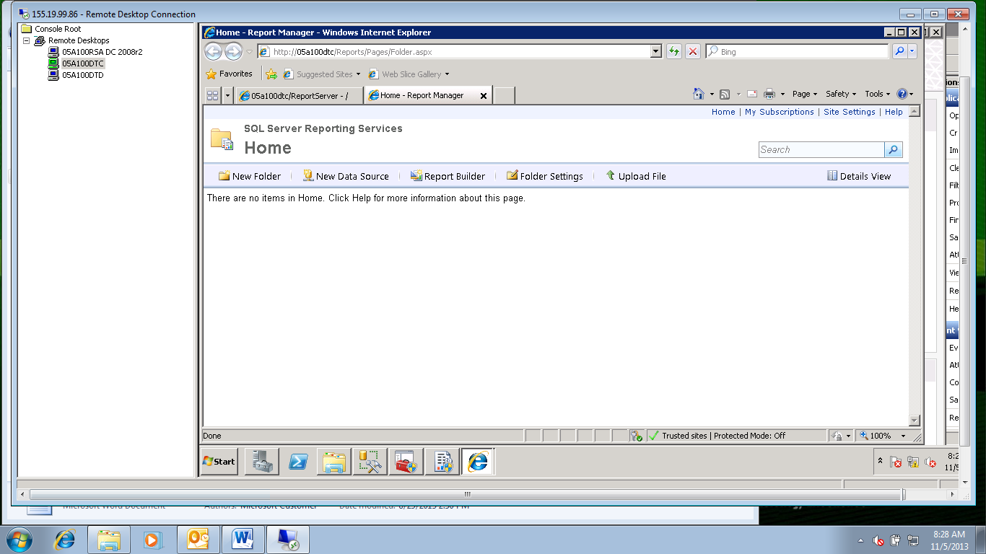

1. Do the above step for any named instances.

* As an example: For an SSRS server (05a100dtc ) that has one default (port 80) and one named instance (port 8080 with the name “REPORTINGINST”) the following URLs should be tested.

<http://05a100dtc/ReportServer>

<http://05a100dtc/Reports/Pages/Folder.aspx>

<http://05a100dtc:8080/ReportServer_REPORTINGINST>

<http://05a100dtc:8080/Reports_REPORTINGINST/Pages/Folder.aspx>

* As an example with SSL: For an SSRS server (05a100dtc ) that has one default (port 80) and one named instance (port 8080 with the name “REPORTINGINST”) the following URLs should be tested.

<https://05a100dtc/ReportServer>

<https://05a100dtc/Reports/Pages/Folder.aspx>

<https://05a100dtc:8080/ReportServer_REPORTINGINST>

<https://05a100dtc:8080/Reports_REPORTINGINST/Pages/Folder.aspx>

1. Keep these URLs open for the next step.
2. If a login prompt appears for any of the URLs please review the browser and Kerberos settings.

## Procedure to verify that Kerberos is being used

NOTE: This step will test that Kerberos is being used for the connections to the reports that were opened above.

NOTE: Local connections on a server will always use NTLM, so you will always see NTLM connections.

1. If you don’t know the database server

* From the SSRS “Reporting “Services Configuration Manager” opened above.
* Click on the “Database” link on the left.
* The “Report Server Database” page will open on the right.
* The database server name is listed after the label “SQL Server Name” as shown below.

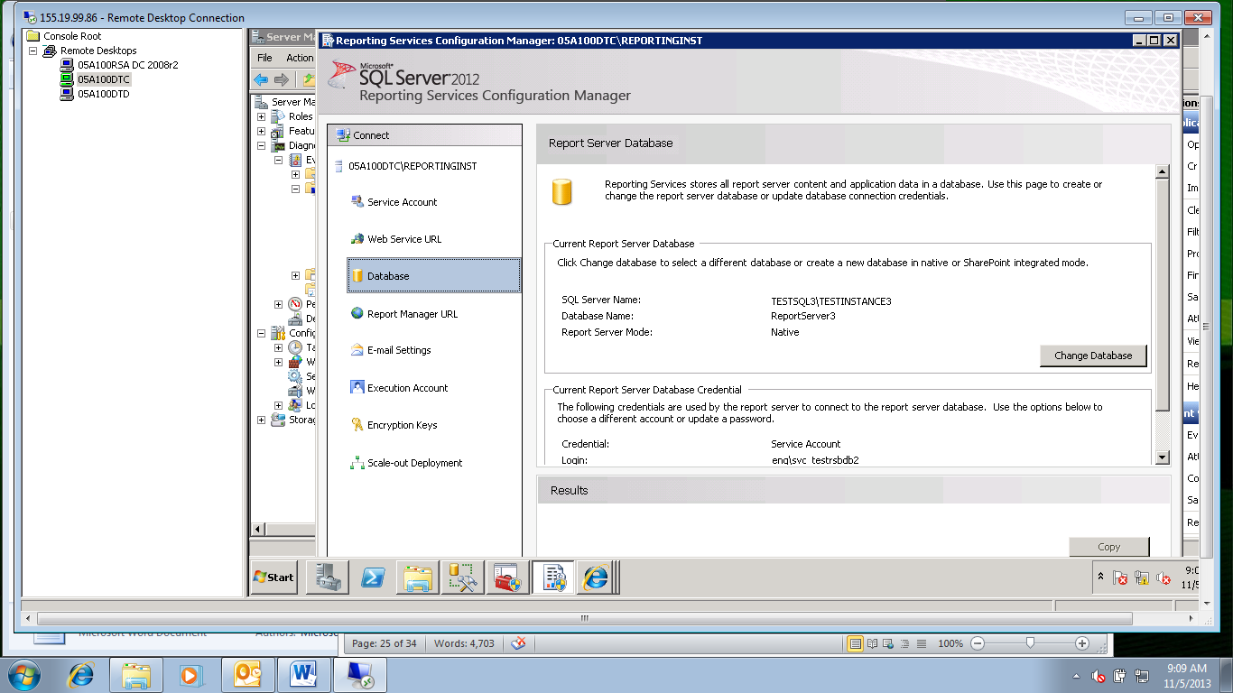

1. Log onto the server that houses the databases that support the SSRS instances whose reports were opened above.

* Name of the server was found in the above step.

1. Open “SQL Management Studio”.

* Click on “Start”, then “All Programs”, then “Microsoft SQL Server 2012”.
* Click on “SQL Server Management Studio” to open.

1. Connect to the SQL instance that will be updated

* In the “Connect to Server” box type the instance name of the SQL instance to be updated.
* Make sure “Windows Authentication” is selected in the Authentication textbox.
* Click “Connect”.

1. Open Query Analyzer

* Right click on the instance name in “Object Explorer” and choose “New Query” from the context menu. The query window will open.

1. Run the query to look at the active connections

* Type the following code into the Query window:

**SELECT CONVERT(VARBINARY(9), protocol_version), auth_scheme, client_net_address, client_tcp_port**

**FROM sys.dm_exec_connections**

* Click “! Execute”.

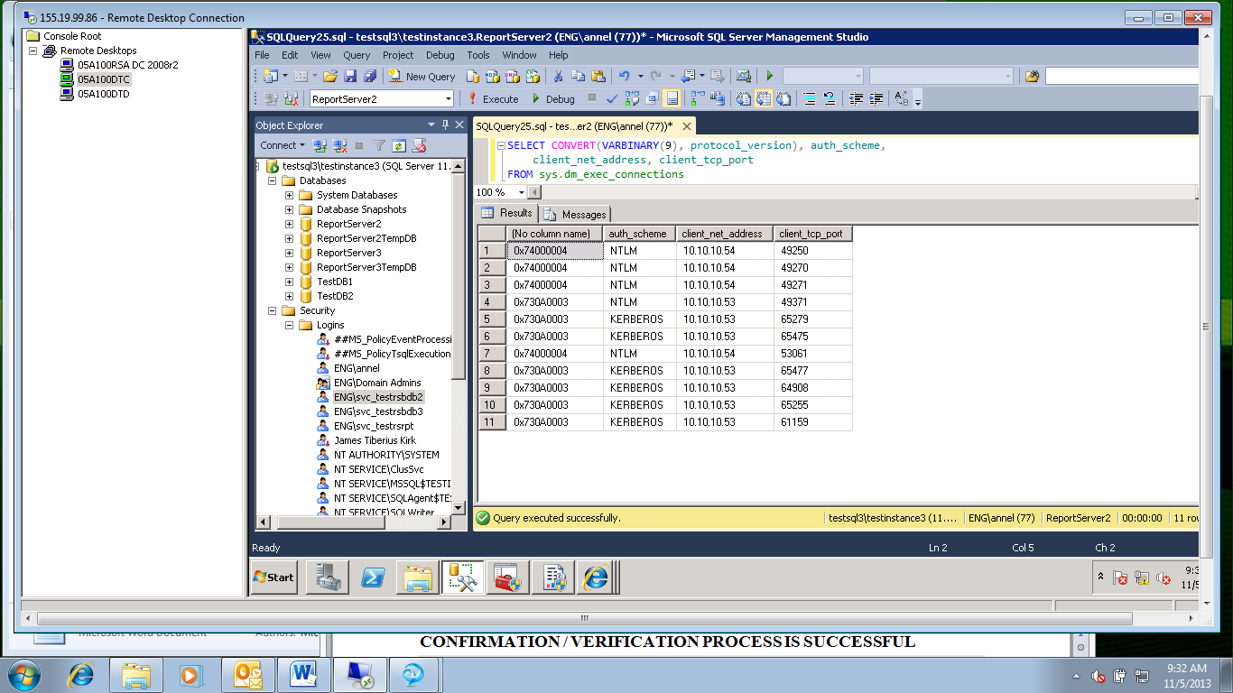

* The key column to note is the “auth_scheme” column. It should show KERBEROS for all of the connections coming from the local server (10.10.10.53) which is converting the remote requests into Kerberos requests for data from the database server. This is what you are looking for.
* Note that the connections on the local server (the server the query was run from, in this case 10.10.10.54) are all NTLM because these are incoming IIS requests. This is correct.
* There is one local request (row 4) that is using NTLM locally. Please ignore this.

# CONFIRMATION / VERIFICATION PROCESS IS SUCCESSFUL

NOTE: There are two ways to confirm the SPN creation. The first is manually via command prompt. The second is using SCOM.

1. Run the following command in the command prompt to list the SPNs created:

**SetSPN – L** <service account>

* This list should match the list of SPNs created above.

1. SCOM (with the latest SQL management pack installed) will issue a warning for any missing, malformed, or duplicate SPNs. Keep an eye out for any problems and correct them when they occur.
2. Verify that all of the reports open
3. Verify that the SSRS service is running.

# CRM 2011 and SQL Server Reporting Services (SSRS) Configuration

CRM 2011 uses SQL Server Reporting Services to provide out-of-the-box custom data sources and reports. Both the D-CATS and CRIMSv2 solutions are versions of CRM 2011 which provide these custom data sources and reports.

NOTE: The D-CATS solution also has an executable run nightly which runs reports and then emails the PDF reports to users. The setup of this job is described below.

This section describes the setup and configuration of SSRS for CRM 2011.

NOTE: Make sure you are using the SQL installation account as described above, while performing the following steps.

## Configuration of SQL Server Reporting Services for CRM

### Installation account Prerequisite Permissions

NOTE: The account used to install SSRS will also be used to install CRM on other servers in the CRM farm.

The account used to install SSRS must have the following rights:

1. Local Administrator on the SSRS Server
2. Local Administrator on the SQL Server used to host the SSRS databases.
3. Sysadmin on the SQL Server used to host the SSRS databases.

NOTE: The steps to grant the above rights to the SQL installation account are covered in the SQL Installation Account document.

1. Organization and security group creation permission in Active Directory

* The steps to grant these permissions will be covered in the CRM Farm installation document

1. Content Manager and Site Administrator rights in SSRS

* The steps to grant these rights are described below.

### Service account and SPNs

The ‘SQL Server Reporting Services’ service uses a domain user service account. It is important that the SPNs be configured correctly in order for Kerberos to work as instructed in the sections above.

NOTE: The ‘Log On As’ account in CRM should be set to this domain user service account.

### Configuration in SSRS for CRM

Follow the instructions aboe in this document to configure SSRS to be part of the CRM Scale-out deployment.

1. Configure SSRS for CRM.

* Please refer to the steps in the default installation of SSRS listed above.

## Installation of CRM Server

NOTE: The installation of the CRM Server 2011 software requires a valid SSRS ReportServer URL. This step describes how to locate this URL from a site that has already been configured. Make note of this URL so it can be used during the CRM Server 2011 installation.

### Get the ReportServer URL

1. Get the ReportServer URL – Continuing from the “Reporting Services Configuration Manager” above.

* Click on the “Web Service URL” link on the left
* This will bring up the “Web Service URL” page on the right. (see screen shot below).



* Under “Report Server Web Service URLs” note the URL after the “URLs:” link.

### Grant the Service Account Rights

NOTE: This step describes how to grant rights to the SQL Installation Account in SSRS which will be used to install CRM on the rest of the servers in the CRM farm.

NOTE: The SQL Installation account will NOT be used to run CRM but will be disabled after the initial installation.

NOTE: There will be an additional CRM account that is used to run the CRM service that needs SSRS rights.

This section describes how to give the SQL installation account Content Manager rights in SQL SSRS ReportServer.

* Click on the “Report Manager URL” link on the left
* This will bring up the “Report Manager URL” page on the right. (see screen shot below).



* Click on the “Reports” URL after the “URLs:” title to open the report manager page.
* The “SQL Server Reporting Services” Home page will open:



* Click on “Site Settings” in the upper right corner of the page.
* The “Site Settings” page will come up.

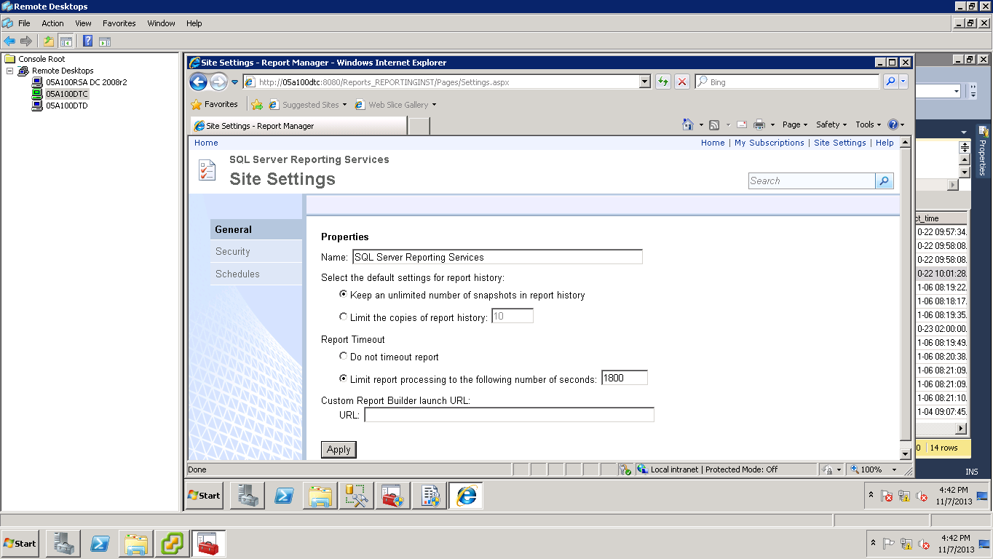

* Click on the “Security” link on the left.
* Click on “New Role Assignment”.
* The “New Role Assignment” page will open.

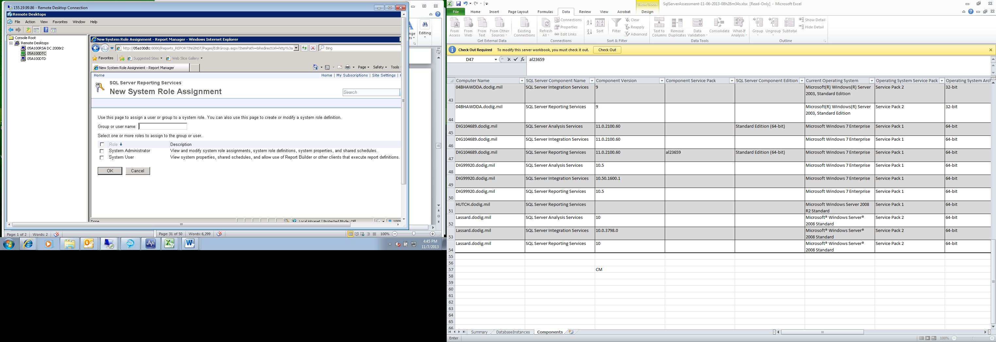

* In the “Group or user name:” textbox type the <domain>\<SQL Installation account>.
* Check the box in front of “System Administrator”.
* Click “OK” to accept.
* The SSRS service account and the SQL Installation accounts should appear in the list of security accounts.
* Click “Home” to go back to the “Home” page.

1. Set the folder permissions for the SSRS account

* Click on the “Folder Settings” link.
* Click on the “New Role Assignment” link.
* The “New Role Assignment” page will open.

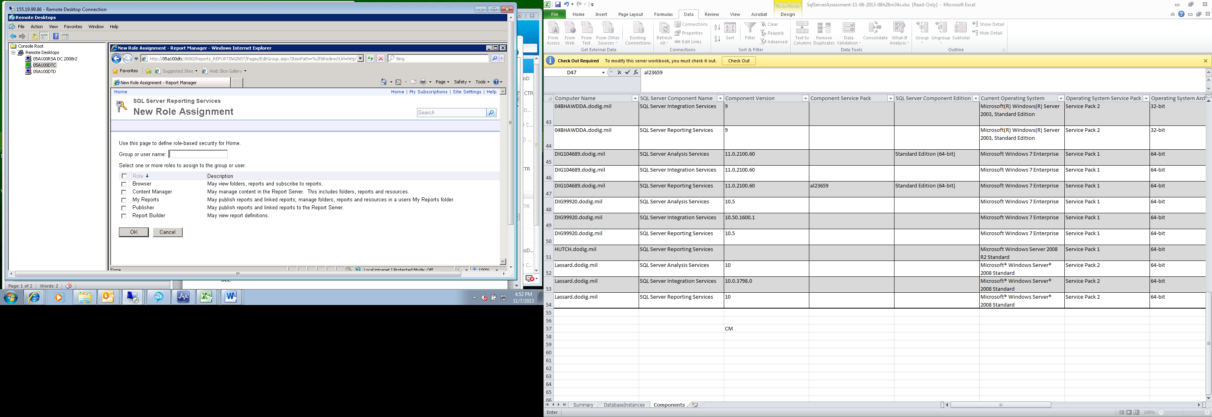

* In the “Group or user name:” textbox type the <domain>\<SQL Installation account>.
* Check the box in front of “Content Manager”.
* Click “OK” to accept.
* The SSRS service account should appear in the list of security accounts.
* Click “Home” to go back to the “Home” page.

## Installation of CRM Reporting Extensions

NOTE: CRM 2011 requires the CRM 2011 Reporting Extensions software be installed on the Windows OS server on which SSRS runs and that CRM 2011 Server utilizes for reporting.

NOTE: You must complete Microsoft Dynamics CRM Server Setup *before* you run Microsoft Dynamics CRM Reporting Extensions Setup.

NOTE: The CRM 2011 Reporting Extensions software is installed one time on the Windows OS of the SSRS server.

To install the CRM Reporting Extensions, locate the Microsoft Dynamics CRM installation files, and follow these steps:

1. Connect to a copy of the CRM Dynamics CRM Reporting Extensions installation files.

* In this example they are on a DVD.

NOTE: Make sure the setup dir structure is:

Server\amd64

SetupSrsDataConnector

Redist\amd64

VCRedist

vcredist_x64.exe

1. Browse to the ..\Server\amd64\SrsDataConnector folder

* Right-click on the “**SetupSrsDataConnector.exe” file and choose “Run As Administrator” from the context menu**.
* The CMR setup window will open.

1. On the “**Welcome to Microsoft Dynamics CRM Reporting Extensions Setup”** page

* Select whether you want to update Microsoft Dynamics CRM Server Setup.

NOTE: It is recommended that, if updates are available, you let Setup download the latest version.

* Click “**Update installation files**”
* Wait until the process is complete.
* Click “**Next”**.

1. The “**License Agreement”** page will appear.

* Click “**I accept this license agreement”**
* **C**lick “**I Accept”**.

1. If Setup detects that components are missing, the “**Install Required Components”** page appears.

NOTE: If there are no missing components this page will not appear.

* The required components are listed.
* Click **“Install”**.
* The components will install.
* Click **“Next”**.

1. The “**Specify Configuration Database Server”** page will appear.

* Enter the name of the computer that is running SQL Server and contains the Microsoft Dynamics CRM configuration database that is named MSCRM_CONFIG, in the form of: <server name>\<instance name>.

NOTE: For a default instance enter the <server name> only.

* Click “**Next”**.

1. The “**Specify SSRS Instance Name”** page will appear.

* Select the Microsoft SQL Server Reporting Services instance that will be used for Microsoft Dynamics CRM reporting
* Click “**Next”**.

1. The “**Select Microsoft Update OptIn”** page will appear.

* Select whether you want to use Microsoft Update for checking for updates for your Microsoft products
* Click **“Next”**.

1. The “**Select Installation Location”** page will appear.

* Click “**Browse”**
* **S**elect the path where you want to install CRM Reporting Extensions.
* Click “**Next”**.

1. The **System Checks** page appears.

* Correct any errors before installation continues.
* Click “**Next”**.

1. The “**Ready to Install Microsoft Dynamics CRM Reporting Extensions”** page appears.

* Click “**Install”**.

1. The “**Microsoft Dynamics CRM Reporting Extensions Setup Completed”** page appears.

* Click “**Finish”**.

1. If you get this error:

* Put content from “Installing SrsDataConnector for CRM 4.0 on 01d019sra “here.

## SSRS Custom Data Source & Stored Credentials

NOTE: For SSRS we set up some reports with a custom data source. These reports are located in a .Zip file that has been copied to the SSRS server.

NOTE: The following instructions describe the process for setting up Auto Generated Reports.

1. From the SSRS server.
2. Extract the .ZIP file into folder and see the individual .rdl files

* At the root of the “C” drive right click and choose “New Folder”.
* Name the folder “ReportsToDeploy”.
* Extract the .ZIP file into the ReportsToDeploy” folder as shown below:

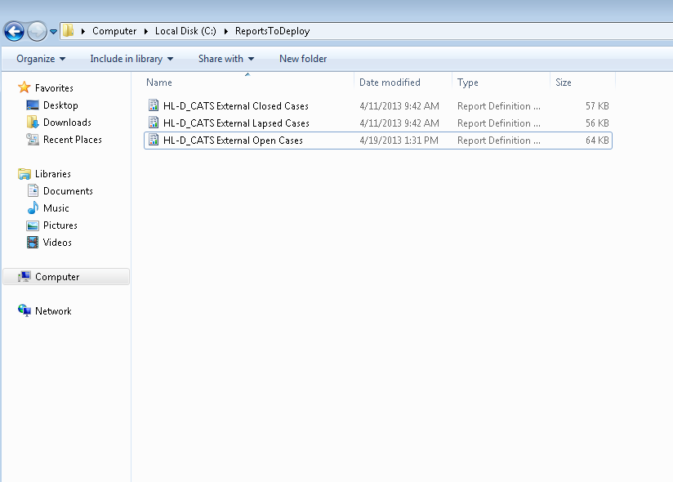

1. Navigate to the *organization_*MSCRM folder on the SSRS Server as an Administrator on SSRS

* Open a browser.
* Type the report address as:

http://<ssrs report server>/reports

* Open the <organization>_MSCRM folder by double clicking on it.

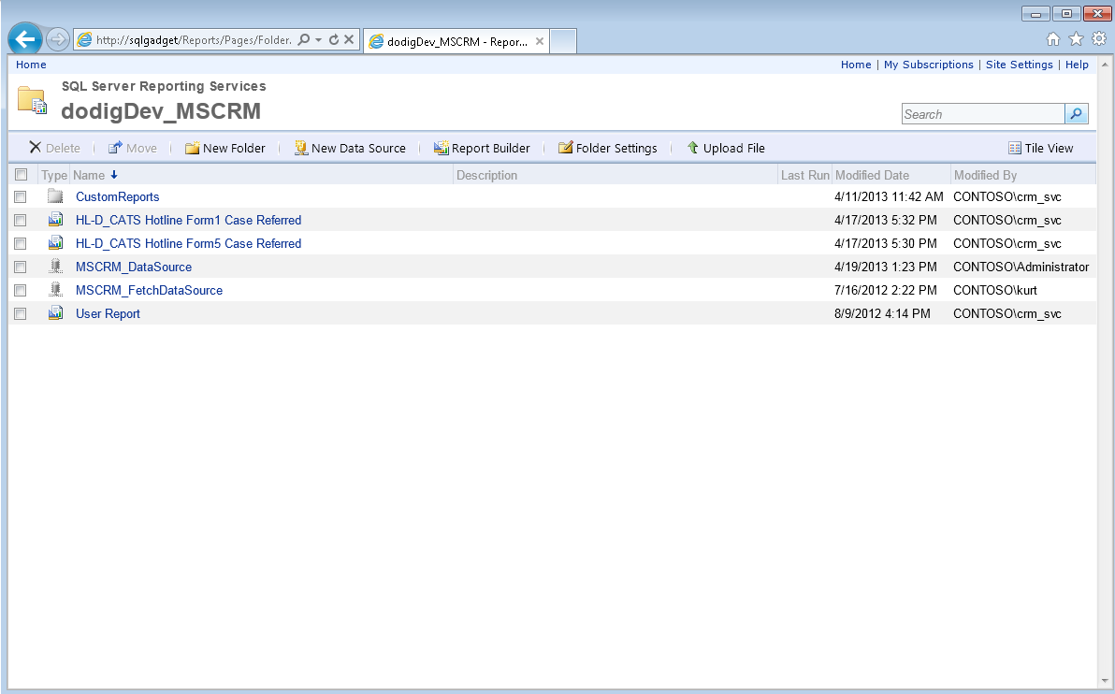

1. Upload the files.

* Click on the “Upload File” button in the navigation
* Select a report.
* Repeat this for ALL reports send in the .zip file. (Reference previous screenshot next to “Folder Settings”)

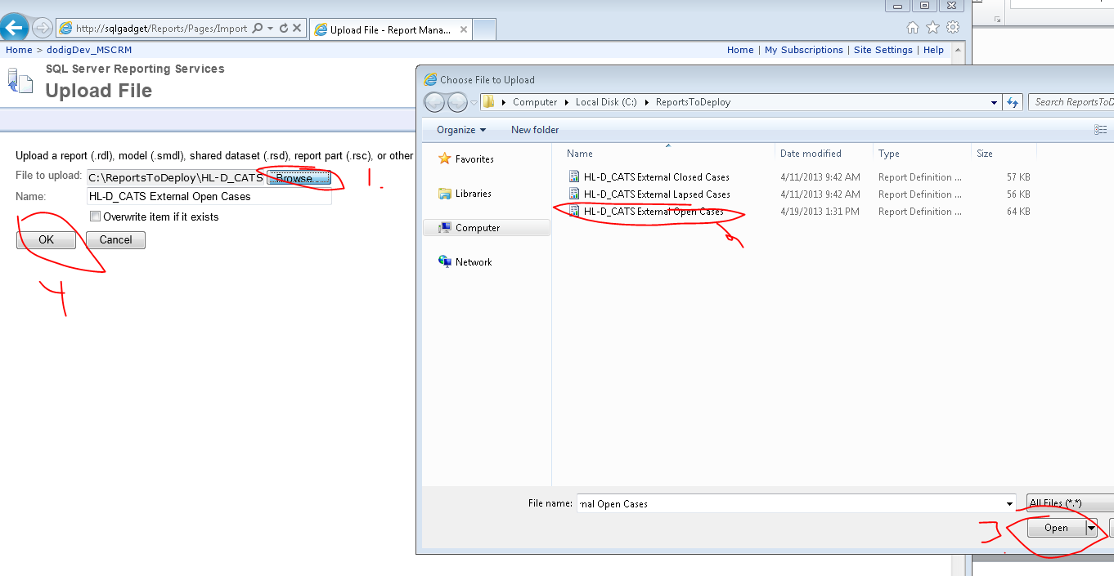

* Your screen should look similar to this:

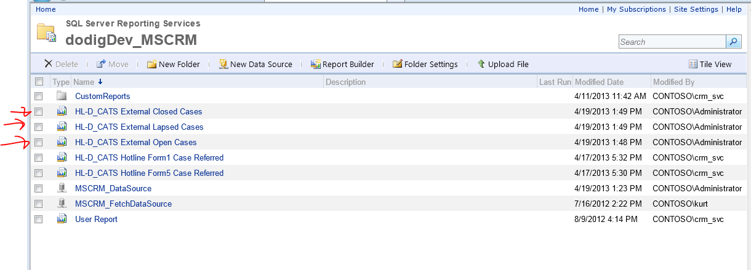

### CONFIGURE THE REPORT’S DATASOURCE

1. From SSRS reporting service website opened above
2. Update the datasource the report uses

* Right-click each report
* Choose “Manage” from the context menu.
* The “Manage Report” window will open.

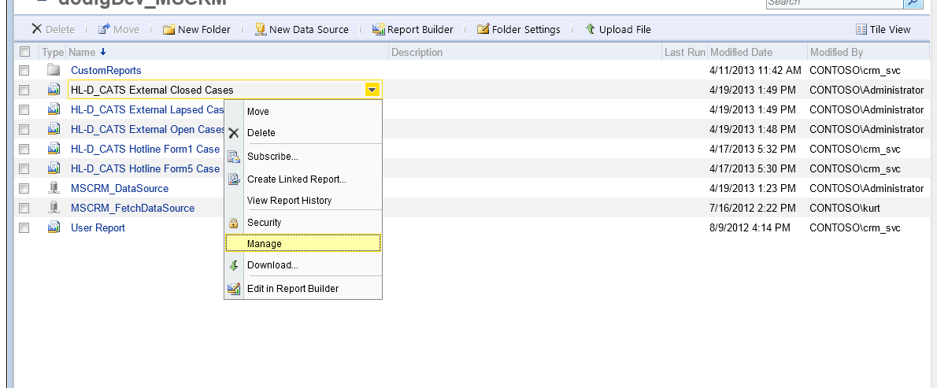

1. Use the “Shared Datasource”

* Click on the “Data Sources” Tab on the left
* Click on “A Shared Data Source” to select
* Then click “Browse”

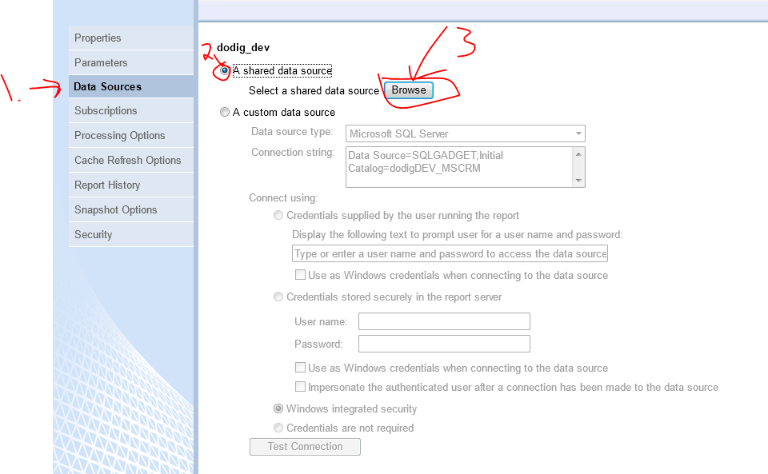

* Click on the folder for your organizations CRM folder
* Select the “MSCRM_DataSource”
* Click “OK”.

Note: This is shown below:

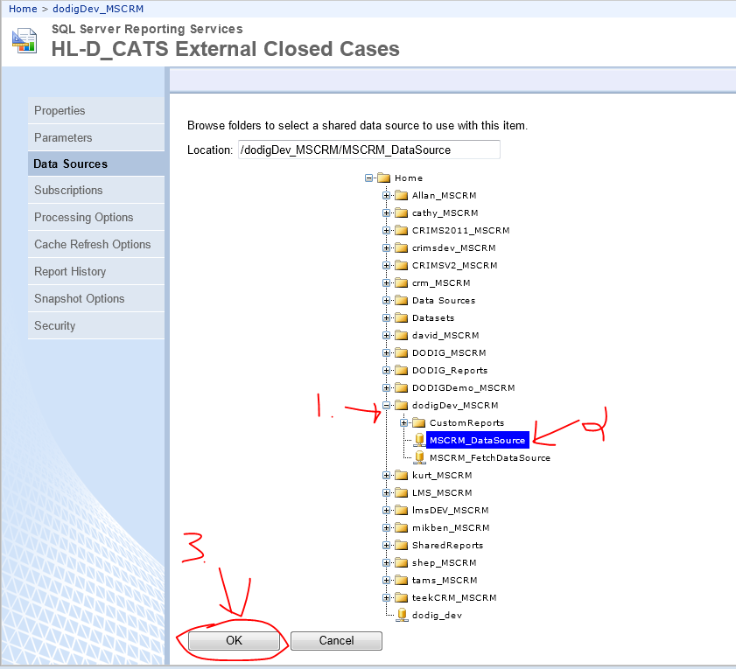

* Click on Apply.

1. Do the next report

* Click on the CRM Organization Folder link at the top
* Do the preceding steps to move the next report.

NOTE: Do this until all reports are moved.

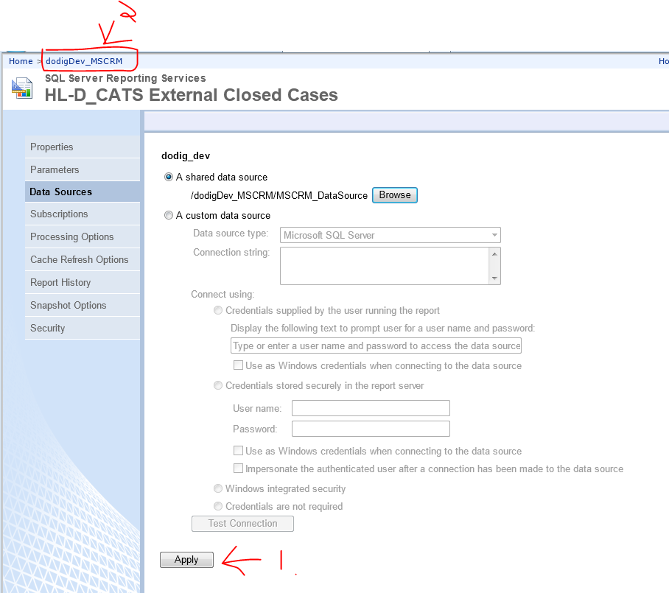

1. Set the shared data source for all of the imported reports

* .Repeat the steps above to set up the shared data source for each report
* You are now finished.

### Setting up a Custom data source Account

NOTE: Because we specify ‘Stored Credentials’ and use a domain user service account’s login and password, the domain user service account must be granted ‘Allow log on locally’ right on the Windows OS on which SSRS runs.

1. From the SSRS server

* Click on “Start”, then “Administrative Tools”, then “Local Security Policy”.
* The “Local Security Policy” will open

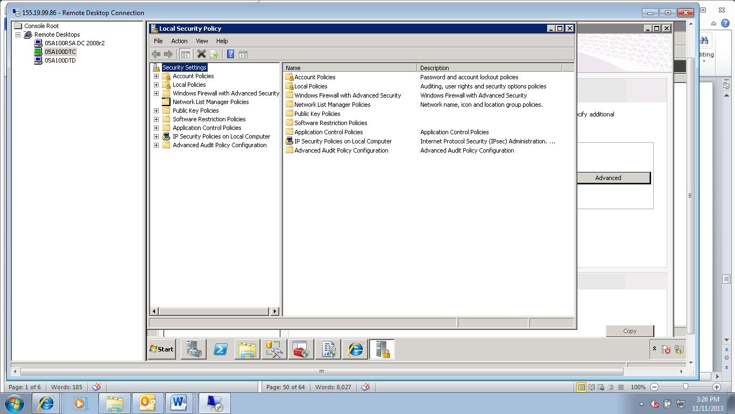

1. Under “Security Settings” on the left,

* Expand “Local Policies”
* Click “User Rights Assignment”.

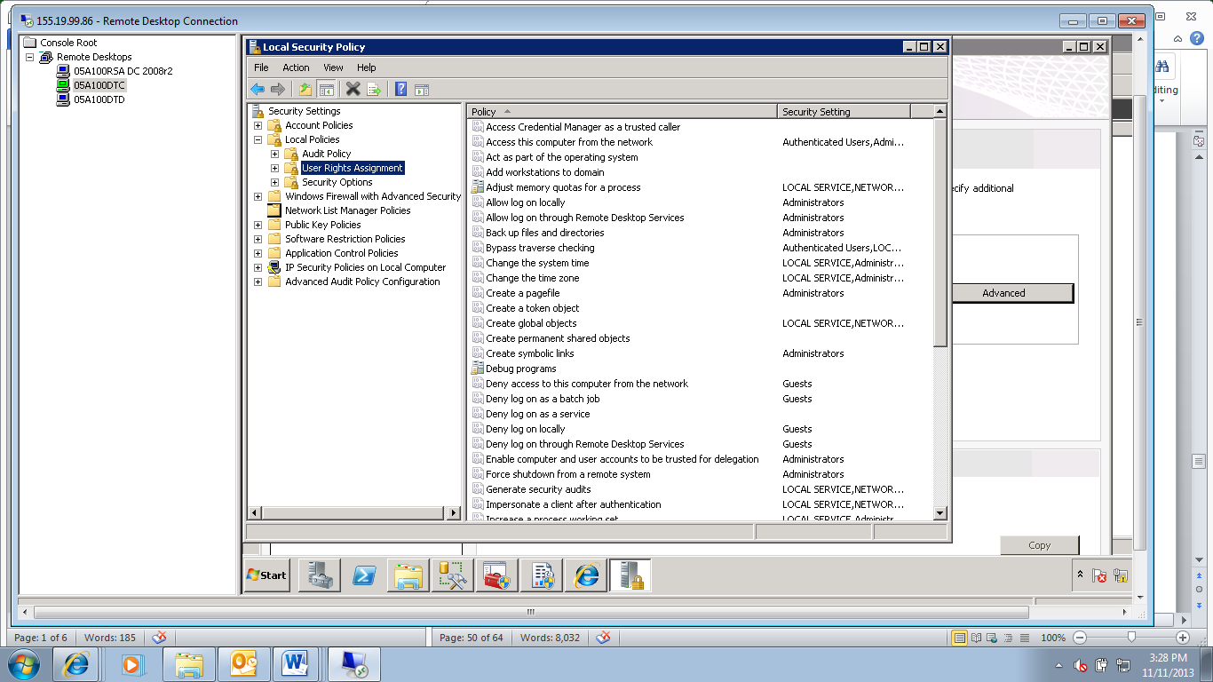

1. In the details pane, right-click Allow log on locally and then right-click Properties.

* Click “Add User or Group”.
* Click “Locations”, specify a domain or other location that you want to search
* Click “OK”.

1. Enter the Windows account for which you want to allow interactive login, the reporting account.

* Click “OK”.

1. In the Allow log on locally Properties dialog box

* Click “OK”.

1. Verify that the account you selected does not also have deny permissions:

* Right-click Deny log on locally and then right-click “Properties”.
* If the account is listed, select it and then click “Remove”.

# CRM Reporting Management and Automated Emailing of PDF Reports

D-CATS contains External Reports. These reports are run against the D-CATS data, turned into a PDF file, and emailed to the agencies to which the D-CATS Complaints & Cases have been referred.

1. Setting Up The Environment

* Log into the CRM Server
* Take the ReportDistribution.zip that contains the executable and extract it to a new folder
* Create or find the folder “DCATS Services” on the C:\ Drive
* Create a folder called “DCATS Report Distribution Application”
* Put the contexts you extracted into that folder
* Right click and edit the “DoDIG_ReportDistributionApplication.exe.config” File
* Change the connection string to the correct url for the crm server.

1. Setting Up CRM to work with Application

* Open up CRM as a CRM Administrator
* Go to Settings-> GadgetConfigs
* Open up the GadgetConfig
* Fill in the following information:

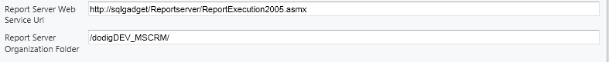

* Fill in the report server information, replacing “sqlgadget” with the servername of the ssrs server used for CRM.
* Specify the organization folder like how dodigdev is an organization, do /*organization*_MSCRM/

1. Getting the Reports Ready for Use by Opening up the Reports section in CRM and follow this process for “HL-D_CATS External Open Cases”, “HL-D_CATS External Lapsed Cases”, and “HL-D_CATS External Closed Cases”

* Check the box next to it and click on edit in the ribbon
* Click on Action in the top menu
* Click on “Publish for External Use”
* Repeat for EACH report
* Reference the screenshot for an example

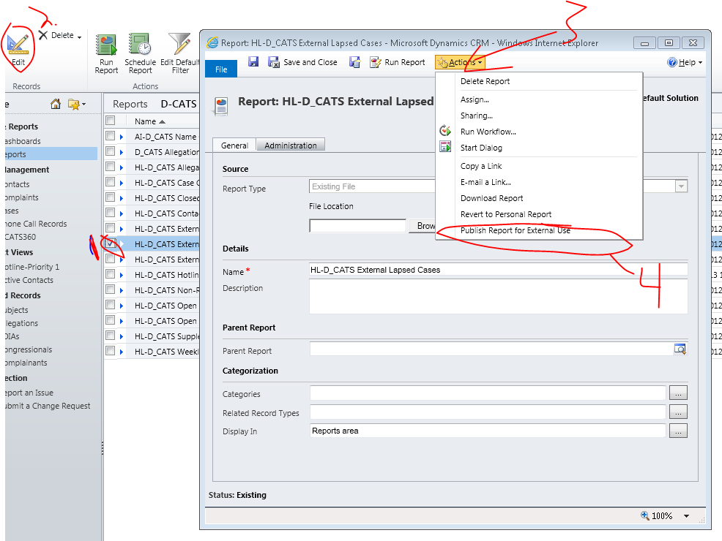

1. Scheduling the Service

* Open up “Task Scheduler” from the start menu
* Click on “Create Task” on the right hand menu
* Fill out the general tab like below:

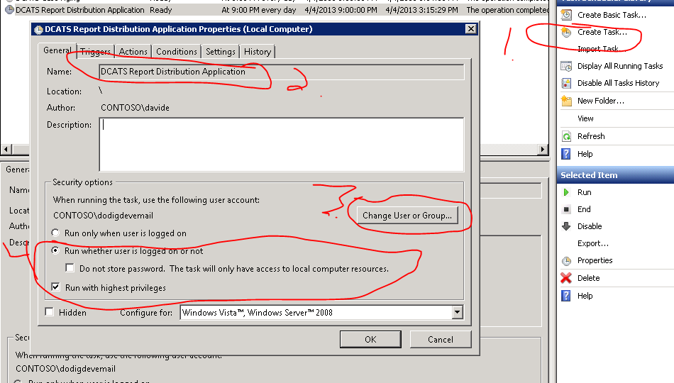

* Fill out the name field
* Change User or Group to the Service Account/Account with Email Privileges
* Select “Run whether the is logged on or not” and “Run with highest privileges”
* Note: if it tells you that the user does not have batch job rights then do the following: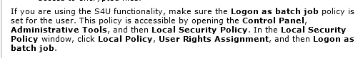
* Create a new trigger and fill out the trigger info like the following using **TODAY’s** date.

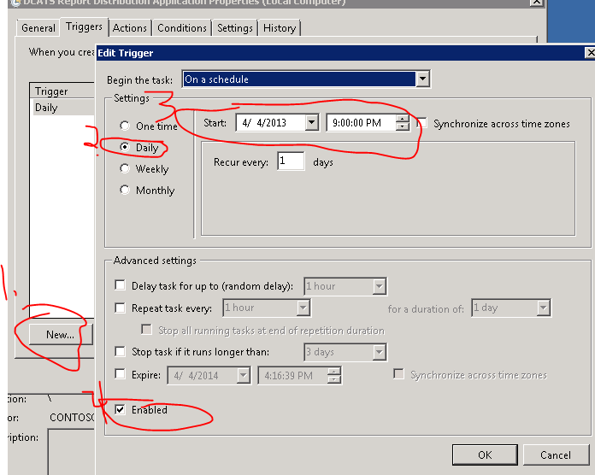

* Create a new Action and fill it out like below:

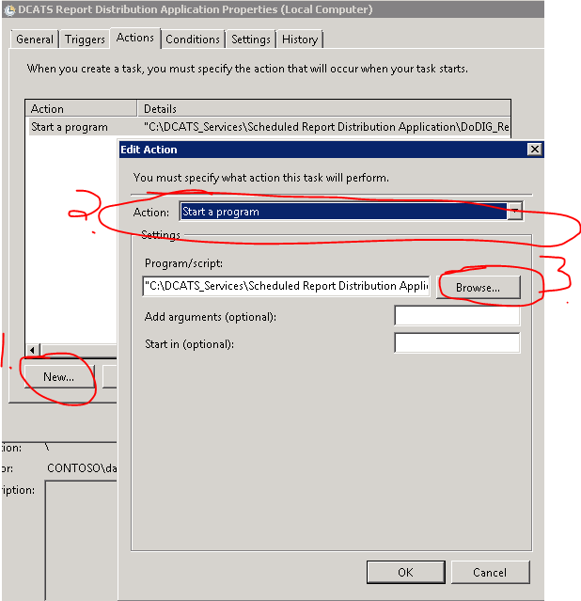

* Note: Under browse, navigate the ScheduledReportDistribution.exe in the folder where you extracted the files earlier.

1. Scheduled Task Is Now Complete.

* Click OK

NOTE: The Windows OS scheduled task that runs the executable that directs D-CATS to run the reports and email the PDF files runs as the user account dod-ig\dcatsforward.

# POST PROCESS CLEANUP

NOTE: Check for and delete duplicates, (delete the duplicate SPNs) if duplicate SPNs were found in the previous section.

|  |
| --- |
| Delete Errant or Duplicate SPN’s |
| NOTE: When deleting an SPN, ensure you are typing the Server Name and User as it appears in the SPN entry you wish to delete. If it is a misspelling of the Server Name or User, you must spell it that way in the SETSPN –D command. |

1. Open an elevated “Command Prompt” window.

* If prompted by UAC, click “Yes” to continue.

1. The “Administrator: …” window displays.

* Type **SETSPN –D MSSQLSvc/**<SERVERNAME or FQDN>**:<**PORT NUMBER**>** **DOD-IG \**<USER>
* Click [ENTER]

Example: **SETSPN –D MSSQLSvc/SQ12-VW-12.DS.DFAS.MIL:1433 DOD-IG \SVC12DBE-0**

|  |
| --- |
| Check for Duplicate SPN’s |
| NOTE: When deleting an SPN, ensure you are typing the Server Name and User as it appears in the SPN entry you wish to delete. If it is a misspelling of the Server Name or User, you must spell it that way in the SETSPN –D command. |

1. Open an elevated “Command Prompt” window.

* If prompted by UAC, click “Yes” to continue.

1. The “Administrator: …” window displays.

* Type **SETSPN –X**

Example: **SETSPN –X**

* Click <ENTER >

1. Sample output is below:

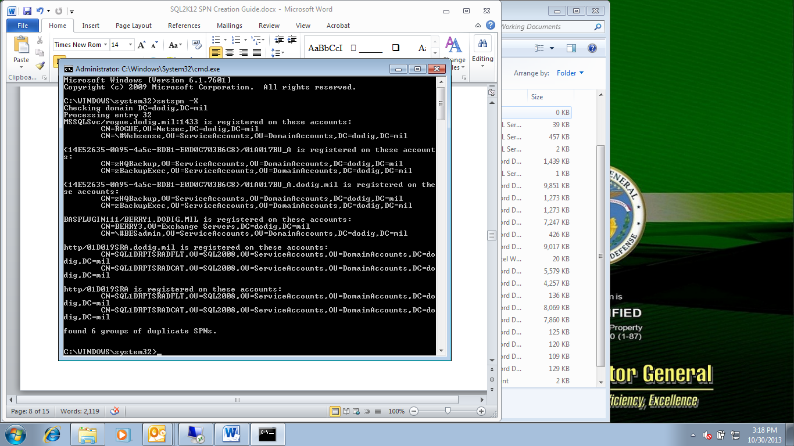

# APPENDIX A

Validation Test Log

A test plan is required to validate system, software, and/or hardware functionality. The test plan aims to ensure that essential system requirements function as intended after the documented procedures are performed.

Perform the following validation tests to verify that the service accounts have been created.

|  |  |  |  |  |
| --- | --- | --- | --- | --- |
|  | **Date** | **Test Action** | **Pass / Fail** | **Results / Comments** |
| 1 |  | On a server that the sql service account has been installed on run in query analyzer:  **select * from sys.dm_server_services** |  |  |
| 2 |  | Verify that the service accounts that were created are listed in the output above. |  |  |
| 3 |  | In the “Services” applet verify that the SQL Services are started. |  |  |
| 4 |  | Verify Clustering |  |  |

# APPENDIX B

References

1. Implement Kerberos Delegation with SSRS: <http://sqlmag.com/sql-server-reporting-services/implement-kerberos-delegation-ssrs>
2. How to Configure Reporting Services: <http://msdn.microsoft.com/en-us/library/aa545752(v=CS.70).aspx>
3. Configuring SQL Server Reporting Services in SQL Server 2012: <http://learnsqlwithbru.com/2011/12/27/configuring-sql-server-reporting-services-in-sql-server-2012/>
4. Configuring Kerberos so SSRS 2012 reports can consume SharePoint 2010 as a data source: <http://blogs.msdn.com/b/bettertogether/archive/2013/10/03/configuring-kerberos-so-ssrs-2012-reports-can-consume-sharepoint-2010-as-a-data-source.aspx>
5. Configure the new Reporting Services instance: <http://technet.microsoft.com/en-us/library/hh389764.aspx>
6. Configuring SSRS 2012 for SharePoint 2010 in a farm: <http://social.msdn.microsoft.com/Forums/sqlserver/en-US/aa14ed8c-8114-4b21-887d-75f5be507927/configuring-ssrs-2012-for-sharepoint-2010-in-a-farm-urgent-please?forum=sqlreportingservices>
7. Configuration and Administration a Report Server: <http://msdn.microsoft.com/en-us/library/ms159624.aspx>
8. Configuring Reporting in Configuration Manager: <http://technet.microsoft.com/en-us/library/gg712698.aspx>
9. How to configure SQL Reporting Services 2012 in SharePoint Server 2010 / 2013 for Kerberos authentication: <http://support.microsoft.com/kb/2723587>
10. SQL Server Reporting Services: <http://en.wikipedia.org/wiki/SQL_Server_Reporting_Services>
11. Configure the Unattended Execution Account: <http://technet.microsoft.com/en-us/library/ms156302.aspx>
12. How to: Configure a Report Server for E-mail Delivery (Reporting Services Configuration): <http://technet.microsoft.com/en-us/library/ms345234(v=SQL.105).aspx>
13. Configure a Native Mode Reporting Server Scale Out Deployment: <http://technet.microsoft.com/en-us/library/ms159114.aspx>
14. Microsoft Dynamics CRM Reporting Extensions general requirements: <http://msdn.microsoft.com/en-us/library/hh699754.aspx>
15. Specifying Credential and Connection Information for Report Data Sources (SSRS): <http://msdn.microsoft.com/en-us/library/ms160330(v=SQL.105).aspx>
16. Configuring SSL Connections on a Native Mode Report Server: <http://technet.microsoft.com/en-us/library/ms345223.aspx>
17. Install Microsoft Dynamics Reporting Server Extensions: <http://msdn.microsoft.com/en-us/library/hh699807.aspx>

# GLOSSARY

**Active Directory –** This is the DODIG approved directory service for domain networks. It is used to authenticate and authorize all users and computers at DODIG.

**AD** – Active Directory

**ADSIEdit MMC** - Active Directory® Service Interfaces Editor (ADSI Edit) is a Lightweight Directory Access Protocol (LDAP) editor that you can use to manage objects and attributes in Active Directory Domain Services (AD DS).

**Availability Database** – This is a database that is a member of an availability group. The database consists of the original (primary) database and one to four read-only copies (secondaries) of the database.

**Availability Group** – This is a container for a set of databases that fail over together ‘as a group’.

**Availability Group Listener** – This is the name of a server that allows clients to connect to in order to access databases in the availability group. The Availability Group Listener connections allows the active database, whether it is the primary or the secondary replica of the Always On Availability group to be accessed regardless of whether the active database is the primary or the secondary replica..

**Availability Replica** – This is the instantiation of the availability group on the SQL instance. It contains a local copy of each availability database for that availability group. There are two types of availability replicas, one primary replica and one to four secondary replicas.

**CCB –** Change Control Board. This meets weekly and is the only body who can approve documents as standard for DODIG.

**Cmdlets** – small commands that are run in powershell for very specific purposes.

**Data –** Information that has been translated into a form that is more convenient to move or process

**Data Store -** A single, general-purpose database that can hold many types of data and distribute that data to users anywhere on the network.

**Domain Account -** Domain Account is an account created in Active Directory, not on the local server.

**DODIG** – Department of Defense Inspector General. This is the body who authorize the creation of these SQL documents and who owns the collateral.

**Group Policy –** This is a feature of Active Directory which allows central control and configuration of the working environment of user and computer accounts.

**Kerberos** - Kerberos is a secure method for authenticating a request for a service in a computer network.

**Local Account -** Local Account is an account created on the server, not in Active Directory.

**Local Policy -** This is a feature of Active Directory on the Local Servers which allows for local control and configuration of the server environment of user and computer accounts. Group Policy overrides Local Policy when a conflict occurs.

**Managed Group Service Account** – A Managed Service Account is a domain account that is managed by active directory. It does not have an explicitly (manually) set password. A Group Service Account is created for the use of a group of servers such as a farm or a cluster, but for use by the same service.

**Managed Service Account** – A Managed Service Account is a domain account that is managed by active directory. It does not have an explicitly (manually) set password. Each service account is created for an explicit server, for a specific service.

**PFE** – Premier Field Engineer. This is the resident SQL Engineer responsible for the creation of the SQL Server Documents.

**Primary Database** – This is the original read-write copy of the availability database.

**Primary Replica** – This is the replica that makes the primary database available for read-write connections. It also sends the transaction log records for each primary databases to each secondary database replica.

**Secondary Database** – This is the read-only copy of the availability database.

**Secondary Replica** - This is the replica(s) that makes the secondary databases available for read-only connections. It also receives the transaction log records from the primary database(s) as well as serves as a potential failover target for the availability group.

**Service Account –** These are accounts used to run SQL (or other application) Services. They are created either locally or in Active Directory.

**SPN** – Service Principal name

**SQL Installation Account** – This is a login account that should be used while performing all initial SQL installations.

**SSAS** - SQL Server Analysis Services

**SSIS** - SQL Server Integration Services

**SSMS** - SQL Server Management Studio

**SSRS** - SQL Server Reporting Services

# SIGNATURE SIGN-OFF

|  |  |  |  |  |
| --- | --- | --- | --- | --- |
| Signature: |  | | |  |
|  | |  | |  |
| Date: |  | | |  |
|  | | |  |  |
| Server Hardware Name: | | |  |  |
|  | | |  |  |
| Discrepancies/Notes: | | |  | |
|  | | | | |
|  | | | | |
|  | | | | |
|  | | | | |
|  | | | | |
|  | | | | |
|  | | | | |
|  | | | | |
|  | | | | |
|  | | | | |